 | Guardian Mobility,  43 Auriga Drive  Ottawa, Ontario, K2E 7Y8.  http://www.guardianmobility.com  Aero SFX Terminal Requirements Specification  Guardian Mobility Document Number: 101965  Date: October 29th 30, 2025

 | Names/Title | Signature | Date
Prepared by: | Steve Courtney  PM
Reviewed by: | Contractor xxxx ??
Reviewed by: | Outerlink xxxx ??
Approved by: | Stephane Momy  CEO

Author | Revision | Date | Change History
Steve Courtney | R 1.0 | 4th March 2020 | Initial Requirements captured from previous marketing documents, Contractor emails and telecoms, and SFX Aero Terminal Requirement - V0.2, dated 26/02/20
Steve Courtney | R 1.1 | 20th March 2020 | Updated with Stephane Momy comments. Restructured Document and added AT commands
Steve Courtney | R 1.2 | 31st March 2020 | Updated with GM comments. Various amendments reflecting deliverables and API control of terminal
Steve Courtney | R 1.3 | 10th April 2020 | Updated with general edits clarifying AFF and code porting and responsibility.
Steve Courtney | R 1.3.1 | 14th April 2020 | Minor edits: AM and APP I/F, VoIP background IP.
Steve Courtney | R 1.3.2 | 20th April 2020 | API LAN port updated, minor edits, added audio codec to terminal, AM CPU/Memory updates, moved video req to optional module.
Steve Courtney | R 1.4 | 8th May 2020 | Added OTA firmware update Modem, Application Module & Router section 6. Added background IP latency to section 3.9. Added MIL-STD-704F for power supply testing section 6.2.
Steve Courtney | R 1.4.1 | 19th May 2020 | Added specs to a/c external Discrete inputs/outputs section 4.1, added UV sunlight Fig 6. Typo corrections, removed steerable antenna section 3.1.4.
Steve Courtney | R 1.4.2 | 22nd May 2020 | Updated after TIM 1 (21st May) Telecom. Super cap 60 seconds relaxed sections 2.2.12, 3.1.1, 3.6.2, Glonass removed, Future RJ11 analog phone future expansion added section 5, “may” added section 3.3.4, PTT clarification added 3.3.3 para 8,OpenVPN update sections 3.3.8,3.16,11.5,IP TOS sections 2.2.19,3.3.3 para 1,PBIT clarifications section 2.3.2,3.14,API clarification sections 2.2.21, 3.15, Terminal mode Password protection added sections 2.3.3,3.7, RS232 s/w flow control added section 3.3.2, warmup period added from -55°C & radome discolor section 3.1.2,figure 6,section 3.3.3 para c & section 3.4.1 para 2, section 3.8 para 6 clarifications, section 3.6.2 para 4 AM updates, section 6 para 4 backward compatibility clarifications, Appendix 13 clarification on usage, 1.5.6 clarification. Typo corrections.
Steve Courtney | R 1.5 | 4th August 2020 | Updates from TIMS’s & related Contractor/GMI email docs : 1. Introduction define 2 Product variants., 2.1 clarification, Updated section 3.1.3 External Connectors,3.1. clarification, 3.3.1 ignition change, 4.1 5.b.4 update,4.2 edge connection clarification,4.1.a.5.i Ethernet clarification,4.4.1.g clarifications, USB removed,4.1.5.b.i.3 Analog input clarification,4.1.5.b.1 update,4.1.5.b.i.6 non IP video req deleted,3.12 Video codec updates,3.6.2 Power Down clarifications,4.4.1.g.vi PSTN clarifications,4.1.5.b.ii antenna updates,3.11 clarification,3.14 BIT loopback clarification, 3.10 SBD replaced by Certus Messaging Protocol,4.1.5.b.i.6 RTC added,3.4 GNSS 5hz update,3.3.3 Ethernet connection updates,3.14 duplicate para numbering fixed,9.3.2 replaced Git Hub with Atlassian/Jira, 3.16- removed encryption from ethernet, 4.3.1.g IMU and Altitude sensor update.
Steve Courtney | R 1.5.1 | 18th August 2020 | 2.1 – ext connector clarification variants ,Fig 7- Updated pinout GMI Variant 1, 3.3.3 -Added 2nd Ethernet port, 3.15.10 & .11 - fixed 2 incorrect reference links, 2.2.5.a, 2.3.3, 3.3.4, 4.4.2, 7.8 - changed Webmin only, 3.7.2 - Webmin content clarification, 3.4.8, 3.15.1, 3.15.2 , 13 AT command_VZSTAT - GPSD update, 2.2.3.a – QoS clarification, 3.14 removed BIT via API, 4.4.1.f - removed serial port firmware update, 5.2- removed 9810, 11.6 and 11.7 - added under responsibilities. 13 AT command _VGPSMODE enhanced,3.7.1 clarification
Erik Nelson, Greg Munroe | R 1.5.1.1 | 21st August 2020 | Contractor added annotations for each requirement: Green – compliant, Yellow - partially-compliant and Red - non-compliant. Blue – notes.
Steve Courtney | 1.5.1.2 | 4th September 2020 | Updated requirements based on R1.5.1.1. Contractor feedback and annotated outstanding issues highlighted in Grey by GMI. Contractor feedback from v1.5.1.1 not updated in this version for clarity.
Erik Nelson, Greg Munroe | R 1.5.1.3 | 10th September 2020 | Contractor updated annotations based on GMI’s feedback and marked each change with a tag (R 1.5.1.3).
Steve Courtney | 1.5.1.4 | 17th September 2020 | GMI updated based on Contractor feedback in teal highlight. Fig 7 pinout PSTN/DIN update,2.2.20.a & 20b updated & 3.1 comment,3.3.1 open/gnd defined,3.3.3 ethernet clarification,3.8 VoIP updates,3.9 clarification,3.10 clarification & 3.15.8 note, 3.11 audio codec updates,4.1.2 clarifications,4.1.5.a comment, clarifications 4.1.5.a.i & 4.1.5.b.i.1 & 4.2.1.1 PSTN update, 4.3.1.a CPU note, 4.4.1.g.i DIN clarification
Erik Nelson, Greg Munroe | R 1.5.1.5 | 24th September 2020 | Contractor updated annotations based on GMI’s feedback and marked each change with a tag (R 1.5.1.5).
Steve Courtney | 2.0 | 30th September 2020 | Clean released copy of requirements. All comments & deleted requirements removed, no other changes to requirement text or section numbering from 1.5.1.5(Contractor). This v2.0 reflects GMI requirements. V1.5.1.5(Contractor) is unchanged and reflects Contractor compliance response to GMI requirements
Steve Courtney | 3.0 | 27th October 2025 | Modified for Dal-D G6S Repo by removing/modifying all TBD’s from V2.0
Steve Courtney | 3.1 | 29th October 2025 | Modified for DAL-D separate multiple requirements into individual traceable requirements for all G6 and G6-S variants.

PROPRIETARY STATEMENT
This document contains Confidential Information of Guardian Mobility Inc.(GMI) and neither the document nor said Confidential Information shall be published, reproduced, copied, disclosed, made available on any website, or used for any purpose other than the purpose indicated by the title above without the express written consent of the duly authorized representative of Guardian Mobility. The recipient of this document agrees to hold in confidence the Confidential Information and acknowledges that written permission is required for any other use of the Confidential Information.
.
This page is deliberately blank

1 INTRODUCTION 10
1.1 SCOPE 10
1.2 PURPOSE 14
1.3 Stakeholder Identification 14
1.4 Market Overview Assessment 14
1.5 DOCUMENT STRUCTURE AND CONVENTIONS 14
1.5.1 Document Structure 15
1.5.2 Conventions 15
1.5.3 Definitions 15
1.5.4 Acronyms and Abbreviations 16
1.5.5 Guardian Mobility and Outerlink documents 20
1.5.6 Regulatory Approvals 20
1.5.7 Industry Standards and related documents 20
2 SYSTEM OVERVIEW 22
2.1 System Modularity 22
2.2 System High Level Requirements 23
2.3 Aero SFX Modes of Operation 24
2.3.1 Aero SFX Power Up and initialization 24
2.3.2 Aero SFX Power up Built in Test (PBIT). 24
2.3.3 Aero SFX Terminal Management Mode. 24
2.3.4 Aero SFX Normal Flight Operation Mode 25
2.3.5 Aero SFX Power down Mode 25
3 BASELINE DETAILED FUNCTIONAL REQUIREMENTS 26
3.1 Aero SFX Physical (G6-B and G6-D variants) 26
3.1.1 Aero SFX Terminal G6S variant 27
3.1.2 Aero SFX Terminal Input Power Range 28
3.1.3 Aero SFX Terminal key Physical specifications 28
3.1.4 Aero SFX External rear panel connectors 28
3.1.5 Aero SFX (G6-B and G6-D variants) Internal Antennas 33
3.2 Aero SFX Terminal Certification 34
3.3 Aero SFX External interfaces 34
3.3.1 Discrete Input 0 34
3.3.2 RS 232 serial bus interfacing 34
3.3.3 Aero SFX Ethernet serial bus interfacing 35
3.3.4 Aero SFX Ethernet/Wi-Fi Router and Local area networking(LAN) 35
3.3.5 Wi-Fi interfacing 36
3.4 Aero SFX GNSS 37
3.4.1 Aero SFX GNSS Position Reporting and Tracking 37
3.5 Aero SFX Iridium Certus network 37
3.6 Aero SFX Power Up and Power Down sequence 38
3.6.1 Aero SFX Power Up 38
3.6.2 Aero SFX Power Down 38
3.7 Aero SFX Terminal Management Mode 39
3.7.1 Local Management 39
3.7.2 Remote Management via Webmin 39
3.8 Aero SFX Terminal VoIP 43
3.9 General data packets 43
3.10 Two Way Messaging using Iridium Certus Messaging Protocol 44
3.11 Audio Codec 44
3.12 Video Codec 44
3.13 On Board Router 45
3.14 Power Up and inflight Built in Test (BIT) functions 45
3.15 Aero SFX API requirements 46
3.16 Aero SFX Encryption requirements 48
4 BASELINE APPLICATION MODULE REQUIREMENTS 49
4.1 Application Module (AM) General Requirements 49
4.2 Application Module G4 (AMG4) 52
4.3 Application Module G4 (AMG4) specific hardware Requirements 52
4.4 Application Module G4 (AMG4) Application Code 54
5 Future Expansion Overview 56
6 Non-Functional Requirements 57
6.1.1 Repair and Overhaul (R&O) 57
6.1.2 Aero SFX Nameplate and labels 57
6.1.3 Warning Labels 58
6.1.4 Electrical Hazard 58
6.1.5 Mechanical Hazard 58
6.1.6 Radiation Hazard 58
6.1.7 Safety 58
6.2 Aero SFX DO-160G EMI/EMC and Environmental 58
7 Assumptions 61
8 Constraints and Dependencies. 62
9 Quality Assurance, Software, Documentation and Certification 63
9.1 Development Process 63
9.2 Quality Conformance Inspections 63
9.3 Software 63
9.4 Documentation Required 64
10 Deliverables 66
11 Appendix A Concept Mechanical drawing 68
12 Appendix B Aero SFX API AT Command Set 69

Figure 1. Aero SFX System Block Diagram 11
Figure 2. Aero SFX Concept internal hardware block diagram 12
Figure 3. Aero SFX packaging concept diagram 13
Figure 4 List of Acronyms and Abbreviations used in this document 16
Figure 5 Aero SFX G6-B Mechanical dimensions 26
Figure 6 Aero SFX G6S variant mechanical dimensions 27
Figure 7 Aero SFX Terminal key Physical specifications 28
Figure 8 Aero SFX Terminal G6-B and G6-D size main Interface Connector Pinout (D38999/20FB35PN) 30
Figure 9 G6S External Pinout 32
Figure 10 DO-160G Environmental Requirements 59
Figure 11 DO-160G EMI/EMC Requirements 60

INTRODUCTION
The Aero SFX Terminal (Aero SFX) is a new commercial airborne product to be developed for Guardian Mobility(GMI) and Outerlink by Contractor for the aeronautical marketplace. The terminal utilizes the Iridium Certus® Mid-band satellite network and specified GNSS networks. This single Line Replaceable Unit (LRU) Aero SFX terminal utilizes a Symmetric mid-band 88kbs/88kbs Modem being developed by Contractor, under license from Iridium.
This system requirement specification is an update to the informal email list of high-level requirements, but uses them as a baseline.
The Aero SFX Terminal shall be available in three variants utilizing common internal modules and form factor:
Guardian Mobility Variant: G6 D size, with expanded I/O utilizing a 37 pin D38999 connector
Outerlink Variant: G6 B size, With a 13 pin D38999 connector.
Guardian Mobility Variant: G6S, with external Iridium, GPS and Wi-Fi antennas.

SCOPE
This Aero SFX Terminal Requirements Specification Document 101965 develops the detailed Aero SFX terminal requirements, and as applicable subsidiary documents are referenced. In the event of a conflict between any other documents (GMI or 3rd party) this Aero SFX terminal requirements specification Document 101965 takes precedence. Subsidiary related reference documents include, but are not limited to those detailed in section 1.5.
The Aero SFX is a permanent installation on the Aircraft. The Aero SFX specification is designed for a non-required and non-essential Aero SFX installation in an Aircraft. The Aero SFX firmware can be classed as DO-178C level E as the operation or failure of the equipment has no impact on the aircrew or aircraft systems. This specification does not detail any COTS ground-based systems or development or application software, nor any remote software.
The following equipment is referenced in this specification:
Aero SFX Terminal Part Number: xxxxxx TBA
Aero SFX Terminal Model Number: xxxxxxx TBA
Other variants may have different part and model numbers.

The Complete System is as shown in Figure 1. Figure 2 outlines the internal hardware sub systems. The Application Module shall be for additional functionality as per section 4. Figure 3 shows the concept Aero SFX packaging which is based on the IRIS Satcom terminal form factor.
Figure 1. Aero SFX System Block Diagram

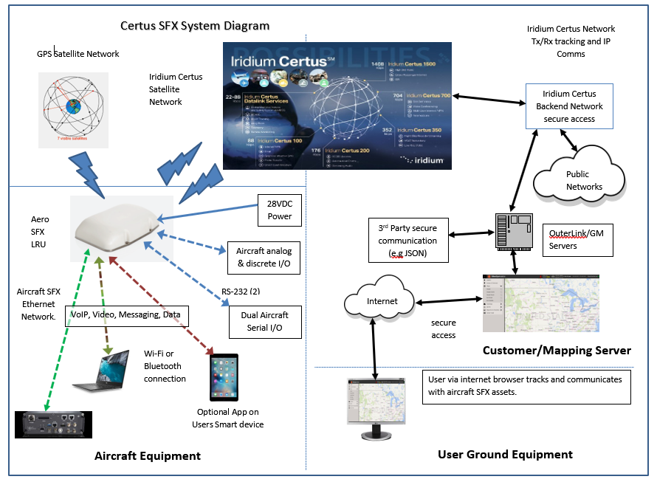

Figure 2. Aero SFX Concept internal hardware block diagram

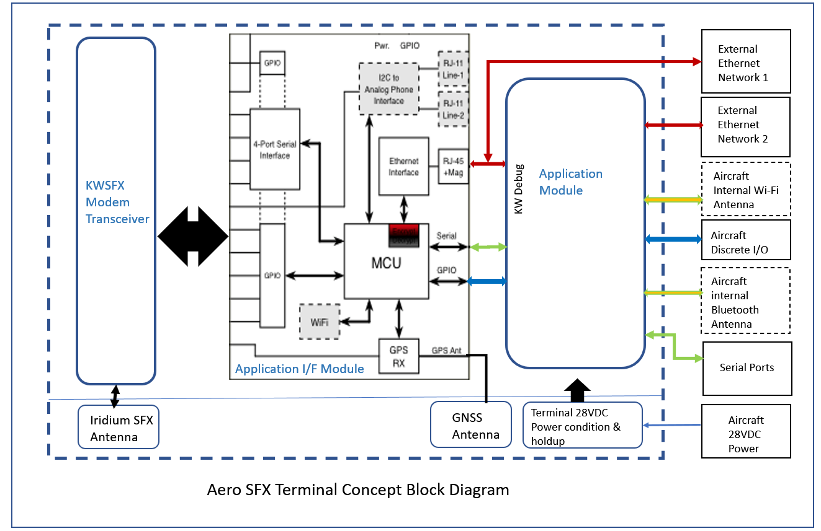

Figure 3. Aero SFX packaging concept diagram
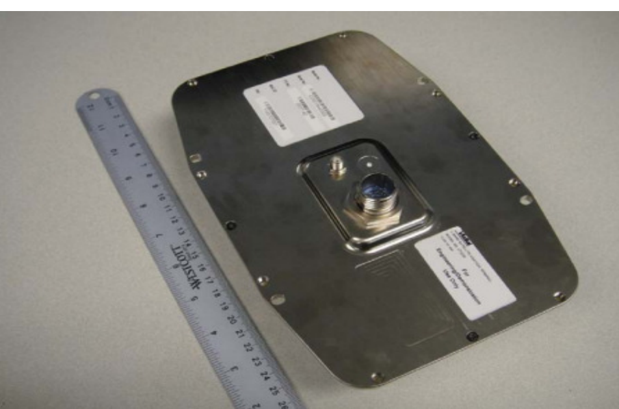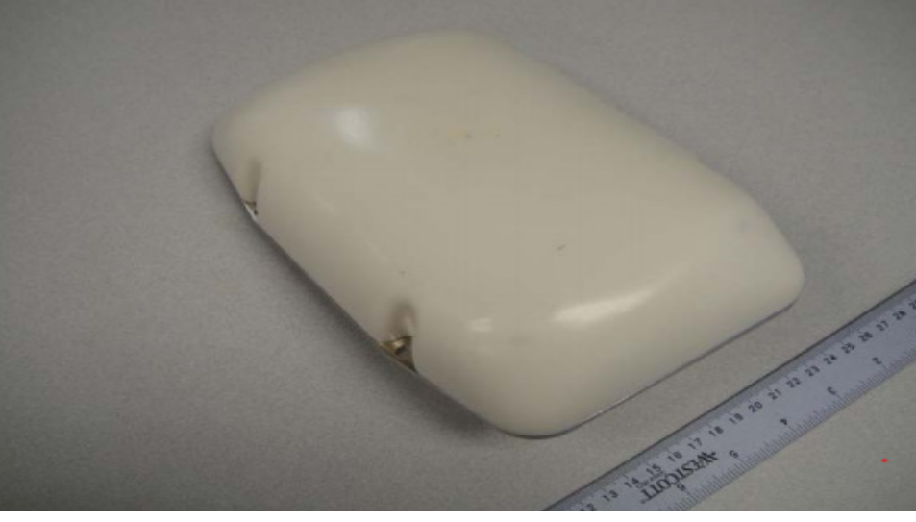

PURPOSE
The purpose of this specification is to define the functional, non-functional and other related requirements including both direct and derived functional requirements for the Aero SFX Terminal.
From this specification an Aero SFX software requirement specification (SRS) and associated hardware and software design documents may be developed by Contractor, leading to product a functional requirements matrix, certification testing and production 1st article.

Stakeholder Identification
The Primary Stakeholders and responsibilities include:
Guardian Mobility (GMI): Responsible for Aero SFX Terminal Requirements, Product Development Management and PM, Design Approval, Launch and Production Customer management, AMG4 Application Code, AFF Certification with USDA….
Outerlink: Aero SFX Terminal Development Financing, Final approvals, General Aero SFX Terminal Marketing.
Contractor: Aero SFX Terminal Development and low volume manufacturing. This may be GMI and other 3rd part companies reporting to GMI as Design authority
Iridium: Responsible for the iridium Certus network, its standards, protocols and associated operation. Iridium is responsible for certifying the Aero SFX modem and terminal for use on its network.

Market Overview Assessment
One of the key objectives and essential to the success is to be the first to market with the Aero SFX with a target cost for the terminal between $1500 to $2000 and modem cost of between $500-700 at wholesale.
Examples of operational scenarios that the Aero SFX Terminal may support range from fleet management, emergency first responders, homeland security forces, disaster aid workers, mobile workforce management and tracking of high-valued assets
Based on market feedback the proposed Aero SFX terminal would be used in the following areas with estimated multi-year volumes of 500-2000 Terminals.
This terminal will expand both GMI and Outerlink product offerings and provide worldwide coverage to existing customers. The additional bandwidth will allow additional value-added functionality to the existing and new customer base such as near real time FDM data, health information, video and much more in a small, cost-effective, light weight package.

DOCUMENT STRUCTURE AND CONVENTIONS

Document Structure

Section 1: Introduction: This section provides the document scope and structure
Section 2: System Overview: This section provides a system description and high-level requirement overview.
Section 3: Detailed Functional Requirements: This section provides a listing of the detailed requirements applicable to the product.
Section 4: Baseline Application Module Requirements
Section 5: Future Expansion Summary
Section 6: Detailed Non- Functional Requirements: This section provides a listing of the requirements applicable to the product.
Section 7: Assumptions- Details any assumptions from any Stakeholder and any assumptions concerning the Product.
Section 8: Constraints and Dependencies. – Details any Product, environmental or regulatory constraints and dependencies.
Section 9: Quality Assurance – Details development process and Certification Requirements.
Section 10: Deliverables – Details deliverables to GM/Outerlink for hardware, software and documentation.
Section 11: Responsibilities - This section details who is responsible for which requirement in this document.
Appendices: Any supporting information that may be required.

Conventions
Unless specifically identified by revision level or release date, the most current issue of documents referenced is applicable to the extent referenced herein.
In the event of any conflict between this document and referenced documents, this document shall take precedence.

Definitions

Shall:
In the context of this specification, the word “shall” in the text expresses a mandatory requirement of the specification. Departure from such a requirement is not permissible without formal agreement between end customer and GUARDIAN MOBILITY.
Should:
In the context of this specification, the word “should” in the text expresses a recommendation or advice on implementing such a requirement of the specification.
Desirable:
In the context of this specification, the word “desirable” in the text expresses a feature or requirement that is either a future requirement, or not mandatory for acceptance of the product.
Provision:
In the context of this specification, the word “provision” in the text expresses a system expansion capability that can be provided in the future, or a hardware capability that can be enabled by a later software release.
May:
In the context of this specification, the word “may” in the text expresses a permissible practice or action. It does not express a requirement of the specification.

Acronyms and Abbreviations
Figure 4 List of Acronyms and Abbreviations used in this document
Acronym | Description
AAC | Aeronautical Administrative Communications
Aero SFX | Proposed Product: Guardian Mobility Aero SFX LRU defined in this specification.
AES | Aerospace Electronic Systems
AES | Aircraft Earth Station
Aero SFX API | The Aero SFX Terminal API using a Contractor defined set of commands to control the Aero SFX terminal from the AM or external system.
AHRS | Attitude Heading and Reference System
AFF | Automatic Flight Following
AM | Application Module providing additional functionality and interfacing beyond the baseline Aero SFX Terminal which consists of the iridium Certus Modem and Application Interface Modules.
AMG4 | Application Module implementing Guardian Mobility G4 Product functionality when integrated with the Aero SFX baseline terminal functionality contained on the Application Interface and Modem modules.
AOC | Aeronautical Operational Communications
APC | Aeronautical Public Correspondence
API | Application Programming Interface (Generic)
ARINC | Aeronautical Radio Incorporated
AT | AT commands are instructions used to control a modem. AT is the abbreviation of Attention. Every command line starts with "AT".
ATU | Auxiliary Telemetry Unit, typically as part of USDA firefighting operations
AWI | Area Work Instructions
BIT | Built in Test.
Certus Messaging Protocol | Certus messaging service similar to existing iridium SBD service.
COTS | Commercial Off the Shelf Equipment
DHCP | Dynamic Host Configuration Protocol
DO-178C level E | Software Considerations in Airborne Systems and Equipment Certification, Level E software is classed as having no impact/effect on the safe operation of the aircraft.
DUT | Device Under Test (e.g. Guardian 6 unit)
EMC | Electromagnetic Compatibility
GPS | Global Positioning System
FMS | Flight Management System.
G4 | Existing Guardian Mobility Product the G4 provides global, real-time user tracking and two-Way messaging in an all-in-one device.
G4LOGS | The GM G4 product automatically logs all activity and failures in Logs called G4LOGS in time and flight sequence for G4 diagnostics. These textual LOGS can be extracted via an external communication port.
Galileo | Global Navigation Satellite System, Europe
GMI | Guardian Mobility Inc.
GMI API | A Guardian Mobility API using G4 Product specific AT commands
GNSS | Global Navigation Satellite System, Supporting multiple GPS satellite networks
GPIO | General Purpose input and Output. In the Aero SFX context this generally means discrete I/O
GPS | Global Position System
GPSD | GPSD is a suite of tools for managing collections of GPS devices and other sensors related to navigation and precision timekeeping.
ICD | Interface Control Document, detailing specific interfaces
IMU | Inertial Measurement Unit typically contains Accelerometer, Gyroscope, Magnetometer, 9 Axis Sensor and serial digital output.
IP66 | Ingress protection IEC standard, protected from total dust ingress and Protected from high pressure water jets from any direction.
IRIS Satcom | IRIS Satcom Terminal marketed by Outerlink
LRU | Line Replaceable Unit
Outerlink | Outerlink Global Solutions
MOD | Modification
MT | Mobile Terminal
NAT | Network Address Translation
OEM | Original Equipment Manufacturer
OOOI | Flight Out from Gate/parked, Out-Take-Off, On-Touch-Down, In-Arrival
OpenVPN | OpenVPN is open-source commercial software that implements virtual private network techniques to create secure connections, and supports AES-256 encryption
OTA | Over the Air via iridium satellite network
PBIT | Power Up Built in Test
PC | Personal Computer
PMA | Parts Manufacturer Approval
PS | Power Supply
PSTN | PSTN stands for public switched telephone network, or the traditional circuit-switched telephone network.
PTT | Push to Talk
PWB | Printed Wiring Board, often synonymous with PCB (Printed Circuit Board)
QoS | Quality of Service
RJ11 | RJ11 stands for “registered jack” and was originally designed by phone companies in the 70's and is used for analog voice lines.
SBD | Iridium Short Burst Data
SDU | Satellite Data Unit
Speex Codec | Speex is an Open Source/Free Software patent-free audio compression format codec designed for speech.
SIP | Session Initiation Protocol used with VoIP calls.
SQA | Software Quality Assurance
SRS | Software Requirements Specification
STC | Supplementary Type Certificate
TBA | To Be Advised
TC | Transport Canada
TCP/IP | Transmission Control Protocol/Internet Protocol,
TOS | IP Header type of service field is the second byte of the IPv4 header. The ToS field can specify a datagram's priority and request a route for low-delay, high-throughput, or highly-reliable service.
UDP | User Data protocol
UUT | Unit Under Test
USB | Universal Serial Bus
VoIP | Voice communication over IP based networks
Webmin | A web-based interface using an internet browser.
Wi-Fi | General term to describe Short range wireless communication as per 802.11.
WoW | Weight on Wheels discrete input

Guardian Mobility and Outerlink documents
The following documents should be consulted whilst designing the Aero SFX. If later versions become available these should be used.
- Guardian Mobility G4 AT-Command Reference – dated 20190819-01, V3.00, Products: G4, G4C, G4MX, G4MXC, 23rd April 2020 (or later version)
- Aero SFX Terminal Statement of Work Document 101968.

Regulatory Approvals
The Aero SFX terminal should be designed to satisfy all necessary requirements, as applicable, to obtain approvals for the following:
- DO-160G and Mil-HDBK-704-8 as per section 6.2.
- CE Per R&TTE Directive 1999/5/EC, Low Voltage Directive 2006/95/EC
- FCC Title 47 Section 15, Title 47 Section 25
- RCM AS/NZS CISP22
- Safety IEC/EN/AS/NZS 60950-1, IEC/EN/AS/NZS 60950-22
- RoHS Per European Union Council Directive 2011/65/EU
- REACH Per European Union Council Directive 1907/2006/EC
- WEEE Per European Union Council Directive 2012/19/EU

Industry Standards and related documents
RTCA/DO-160G Environmental and EMI/EMC Conditions and Test Procedures for Airborne Equipment suitable for both helicopter and fixed wing as per section 6.2.
MIL-HDBK-704-8/MIL-STD-704F Guidance for Test Procedures for Demonstration of Utilization Equipment Compliance to Aircraft Electrical Power Characteristics 28 VDC.
EIA/TIA-232-E Interface between Data Terminal Equipment and Data Circuit-Terminating Equipment Employing Serial Binary Data Interchange.
Ethernet – commercial computer networking protocol and technology.
TCP/IP and UDP protocol.
Bluetooth 4.0 or higher version low energy specification and associated updates and revisions.
WLAN IEEE 802.11 - set of standards for implementing wireless local area network (WLAN) computer communication in the 2.4 and 5 GHz frequency bands.
Iridium Certus® is an advanced multi-service platform enabled by the upgraded Iridium®
constellation. Offering L-Band data throughput providing capabilities to support mobile satellite
communications across maritime, IoT, aviation, land mobile, and government applications.

AT command interface (Base ETSI GSM 07.07 standard).

IRIS Satcom Terminal Brochure.

Atlassian Bitbucket (git) repositories, Jira ticket management.

SYSTEM OVERVIEW
The nominal 28VDC powered Aero SFX is an aircraft system iridium network satellite terminal which can perform automatic real-time flight following, 2-way text/data messaging processing, VoIP communication and other capabilities. Top Level Requirements:
- The Aero SFX shall utilize the Iridium Certus network in a synchronous 2-way networking mode (88Kbs Up/88Kbs Down) and the GNSS satellite networks for position.
- The Aero SFX shall be an IP based data terminal supporting multiple prioritized data streams.
- The Aero SFX shall be a single LRU integrated unit externally mounted with externally facing iridium/GPS antennas, and internal to aircraft SMA, general I/O and power D38999 series connectors.
- The Aero SFX Terminal shall enable reliable and low latency IP-based communications via satellite for commercial rotor and fixed-wing aircraft.
- The baseline Aero SFX system shall consist of the following two sections, both controlled by the same Aero SFX API:
- Form, fit, function replacement for the IRIS Satcom terminal, with an API AT command and TCP/IP and UDP based ethernet/Wi-Fi interface, operating on the iridium Certus network. Typically, the Aero SFX Terminal, consisting of the Aero SFX Modem and Application Interface Modules, would be controlled by an external computer device (e.g. IRIS Control Head) via the Aero SFX API.
- Utilizing a version of the internal Application Module(AM), referred to as the Application Module G4 (AMG4) the Guardian G4 product functionality shall be realized by controlling the Aero SFX Terminal Modem and Application Interface Modules, from the AMG4, via the Aero SFX API.
- Additional external interfaces may be present in Product variants.

System Modularity
The baseline Aero SFX Terminal shall be designed to support three product variants:
- Aero SFX Terminal(G6-B size) with an Iridium Certus Modem and Application Interface Modules, and internal iridium and GNSS antennas, controlled by an external Application System, via the Aero SFX API over ethernet or Wi-Fi, similar to the IRIS Satcom terminal. An Application Module may or may not be installed. – Outerlink Product Variant (13 pin D38999 Connector).
- Aero SFX Terminal(G6 D size) with an Iridium Certus Modem and Application Interface Modules, and internal iridium and GNSS antennas, controlled by an internal Application Module(AM) via the Aero SFX API over ethernet. The Application Module for the baseline shall be the AMG4. – Guardian Product Variant (37 Pin D38999 Connector).
- G6S Terminal with an Iridium Certus Modem and Application Interface Modules, and external iridium, GNSS and Wi-Fi antennas, controlled by an internal Application Module(AM) via the Aero SFX API over ethernet.
- Application Modules in the future may support additional or alternate applications and combinations as summarized in Section 5.

System High Level Requirements
The following are the high-level requirements, priorities, mandatory and desirable functions for the Aero SFX aeronautical terminal for the design, certification (Iridium, DO-160G and regulatory), and delivery of the Aero SFX Terminals.
Mandatory Requirements:
- For the Aero SFX Terminal (G6-B size) and Aero SFX Terminal (G6-D size) varients:
All in one terminal shall be mounted outside the aircraft with a single SFX modem capable of 88/88kbps, and have internal Iridium Certus and GPS antennas and external Wi-Fi antenna.
- For the Aero SFX Terminal(G6-S) varient:
The terminal shall be mounted inside the aircraft with a single SFX modem capable of 88/88kbps, and external Iridium Certus,GPS and Wi-Fi antennas
- Able to transmit every 10 seconds in background IP mode.
- IP based Data only (must support PTT implementation of VoIP)
  - Have ability to set quality of service (ex: prioritize voice vs data) using built in router and available Certus Channels/UARTS.
- Build in GPS (WAAS) and redundant GPS (e.g. Galileo)
- Wi-Fi 802.11 – B/G 2.4 GHZ with software disable.
  - Wi-fi Webmin access used for maintenance, verification, configuration and status
  - Desirable: Able by User configuration to be used as a hot spot
  - Password controlled with high level of security
- Have configurable GPIO of analog inputs, discrete I/O and serial ports
- Shall be Iridium Certus certified
- Have same certification as other Iridium modems
- D0-160G EMI/EMC and environmental as per Appendix A with 3rd party report and signature
- Power input 12-32VDC with power conditioning (note must handle inrush current on helicopter)
- Have super capacitor to support controlled shutdown and OTA power down messaging after loss of 28VDC power.
- AT command interface (Base ETSI GSM 07.07 standard) or équivalent
- Support UDP & TCP communication
- Router supporting Wi-Fi and Ethernet
- Autonomous GPS Position tracking (Automatic Flight Following)
- Provide software access to Serial port/GPIOs to Outerlink and GMI such that Outerlink or GMI can provide tracking messages.
- Diagnostic tools for troubleshooting and installation (BIT)
- Encryption AES-256 and or VPN
- Firewall with QoS
- Multiple IP address based on service type or IP TOS.
- DNS
- Physical:
  - For the Aero SFX Terminal (G6-B size) variant shall have the same footprint/mounting at per drawing in Appendix A for product variant Legacy/Outerlink (D38999/20FB35PN) “B” type connector.
  - For the Aero SFX Terminal (G6-D size) variant shall have the external connector protrusion or baseplate connector well depth increased to accommodate cabling from the D38999 connectors type C and D. Regardless of type B, C or D connector the footprint/mounting shall have the same placement, length, and width.
  - For the G6S variant a different form factor of 11in Long by 5.75in Wide by 1.84in Deep, with the same 13pin D38999 B size connector as per the G6-B size, and also a 26pin HD26 connector for additional I/O.
  - All variants shall not exceed a weight of 2.00KG excluding external mating connectors and mounting hardware (e.g. screws, gaskets)
  - For the Aero SFX Terminal (G6-B size) variant the external connector as shown per drawing in Section 11.
- Memory for code scripting/application software at the application level controlling the terminal via an API
- Webmin tool to configure and provide status of the terminal.
Desirable features:
  - Bluetooth – 4.0+.
  - Iridium Certus Messaging Protocol similar to existing iridium SBD service support when available on Iridium Certus.
  - Remote status of the terminal for troubleshooting purposes

Aero SFX Modes of Operation
The Aero SFX shall provide the following modes of operation:

Aero SFX Power Up and initialization
After Power is applied to the Aero SFX the Aero SFX shall initialize all internal hardware and firmware then execute a Power up Built in Test.

Aero SFX Power up Built in Test (PBIT).
- The PBIT shall always occur after an Aero SFX power cycle to ensure the health of the Aero SFX.
- The Aero SFX should test all internal hardware, as practical, as part of PBIT, results accessible by the Aero SFX API.
- Only if PBIT passes shall Aero SFX flight normal mode be allowed. Desirable: If after a non-critical PBIT failure (e.g. Wi-Fi, Bluetooth, External I/O) and Certus and GPS functionality are still available, then the Aero SFX Terminal should, where practical, allow auto tracking reporting OTA Iridium Certus and system status reporting.

Aero SFX Terminal Management Mode.
A password protected access mechanism shall be provided to allow a User logged in via ethernet, Wi-Fi or via iridium OTA to place the terminal into an Aero SFX Terminal management mode, accessible by Webmin.

Aero SFX Normal Flight Operation Mode
After successful completion of Aero SFX PBIT the Aero SFX may enter normal flight mode, which shall allow full control by the Aero SFX API.

Aero SFX Power down Mode
- After successful detection of loss of Aero SFX power input the Aero SFX shall attempt to send 1 last shut down iridium GNSS position report message whilst the internal power hold up system maintains power.
  - This feature shall be enabled/disabled via Webmin.
- The Power down last position report and may send it at power up if it was unable to send at power down. See section 3.6.2 for additional detail.

BASELINE DETAILED FUNCTIONAL REQUIREMENTS
This section contains the common baseline requirements for the Aero SFX Terminal supported utilizing the Contractor Modem and the Application Interface Module. Section 4 details the additional requirements for the Application Module. Section 5 outlines the future expansion requirements.

Aero SFX Physical (G6-B and G6-D variants)
- The Aero SFX should mount externally to the aircraft with a clear view of the sky using 4 fasteners and an environmentally sealed mount as detailed in Figure 5 and Appendix A.
- The Aero SFX should be 225mm L*146mm W*53mm H (8.86"L x 5.75"W x 2.09"H).
- The Aero SFX should not exceed 2 kilograms (4.4lbs) in weight and aerodynamic consideration should be given to the packaging to minimize drag.
Figure 5 Aero SFX G6-B Mechanical dimensions

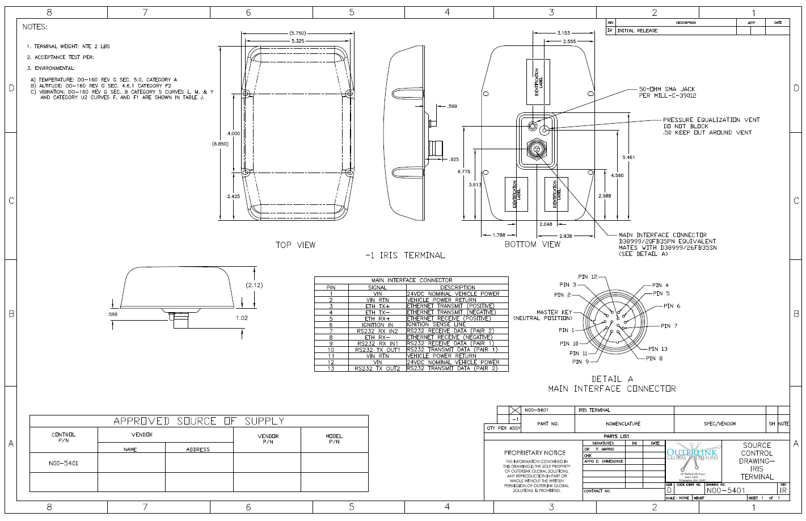

Aero SFX Terminal G6S variant
- The Aero SFX G6S should mount internally to the aircraft as detailed in Figure 6.
- The Aero SFX G6S should be W 14.6 cm (5.75”) x L 28 cm, (11.0”) x H4.7 cm (1.84”).
- The Aero SFX G6S should not exceed 2 kilograms (4.4lbs) in weight.
Figure 6 Aero SFX G6S variant mechanical dimensions

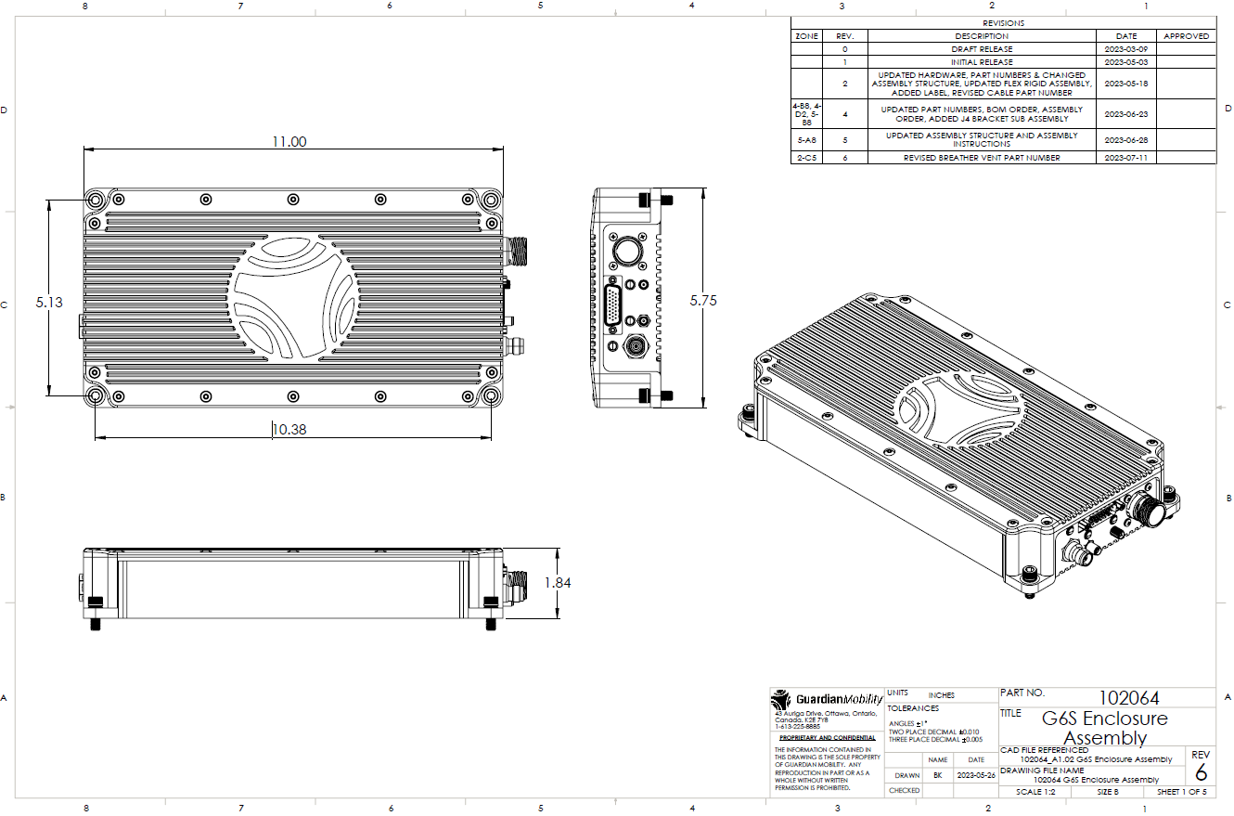

Aero SFX Terminal Input Power Range
The Aero SFX shall function in a typical DO-160G EMI/EMC commercial avionics environment, with a 12VDC-32VDC input range. The Aero SFX power input shall also not be affected by typical Helicopter in rush currents and have EMI/EMC lightening protection. The Aero SFX shall consume less than 15 Watts when not transmitting and a maximum of 65 Watts when transmitting on iridium, Bluetooth and Wi-Fi simultaneously.
The Aero SFX Terminal shall incorporate super capacitors that can support controlled Aero SFX terminal shutdown, as per section 3.6.2, across all environmental conditions, for a total loss of Power.

Aero SFX Terminal key Physical specifications

Figure 7 Aero SFX Terminal key Physical specifications
Category | Specification
Power input voltage | 9-32VDC operating range, with power down holdup time, not using batteries.
Power consumption | Max 65 watts
Operating Temperature | -40°C to +71°C with warm up time allowed from -55°C to -40°C
Storage Temperature | -40°C to + 85°C and DO-160G ground survival testing paragraph 4.5.1 for category B2.
Waterproof/Ingress Protection | IP66 wet service operation
Humidity | up to 95% condensing at 55°C, and ambient
Sand and dust | Sand and dust proof at +55˚ C and ambient
Vibration (Operational) | Random vibration of 1.05g rms at vibration spectrum:  5 to 20 Hz: 0.02g2/Hz  20 to 150 Hz: -3dB/octave
Fluid susceptibility | Continuous spray of de-icing fluid
Salt Fog | 48-hour continuous exposure
Sunlight: UV Stable | Radome materials to be used that do not become brittle or discolor, in sunlight over time.
EMI/EMC | As per Figure 11 DO-160G EMI/EMC Requirements
Environmental | As per Figure 10 DO-160G Environmental Requirements
.

Aero SFX External rear panel connectors
The Aero SFX product variants shall have the following external connectors and associated provisions mounted on the rear panel:
- Outerlink Product Variant G6-B: Quantity 1 D38999/20FB35PN connector, suitable for commercial avionics, for all non-RF signals should be provided. Pinout shall be as per Figure 8. The mating connector shall be D38999/26FB35SN. Connectors shall be positioned as per
- Guardian Mobility Product Variant G6-D: Quantity 1 D38999/20FD35PN connector suitable for commercial avionics, for all non-RF signals should be provided.
  - Pinout shall be as per Figure 8.
  - Connectors shall be positioned as per Figure 5. See also section 4.
  - Also provision physically, in the mechanical and circuit board design layout, shall be made to support an alternative connector, in place of the D38999/20FB35PN connector, for future product derivatives, supported by the Application Module, namely a D38999/20FC35PN.
  - SMA RP jack for optional external Wi-Fi antenna.
- Guardian Mobility Product Variant G6S:
  - 13 pin D38999/20FB35PN connector for DC Power and external I/O.
  - HD26 connector for expanded I/O.
  - SMA RP jack for optional Wi-Fi antenna.
  - TNC jack for the external Iridium Certus antenna and
  - SMA jack for the external GPS antenna.
- All connectors shall be located with sufficient space around each connector to allow for easy attachment of mating connectors.
- Each connector shall be clearly labeled.
- A pressure equalization vent shall be provided as per Figure 5.

Figure 8 Aero SFX Terminal G6-B and G6-D size main Interface Connector Pinout (D38999/20FB35PN)
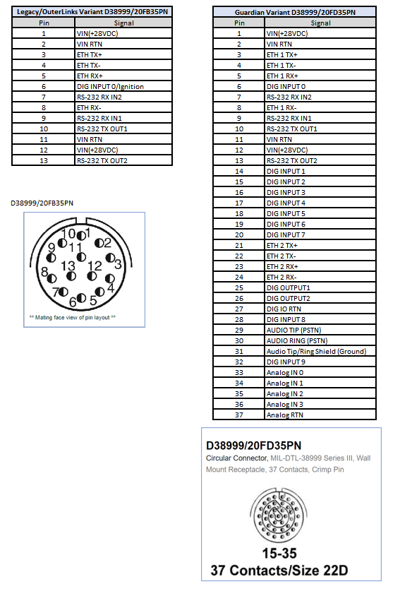

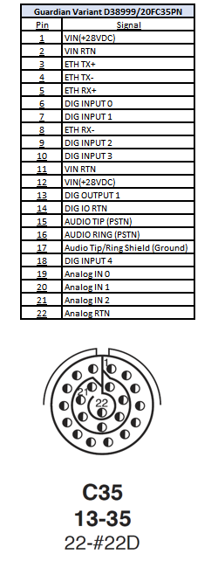
Guardian Mobility Product Variant 2(Future Provision) for reference only

Figure 9 G6S External Pinout
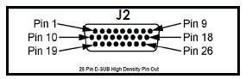
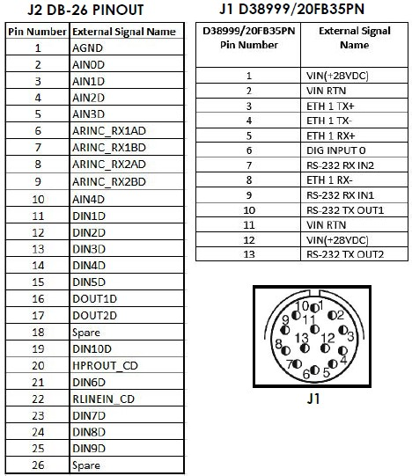

Aero SFX (G6-B and G6-D variants) Internal Antennas
The Aero SFX Terminal shall contain antennas for GNSS and iridium Certus network as follows:
- The iridium antenna shall be an iridium certified antenna, or shall be certified during product certification.
- The GNSS antenna shall support commercial GPS and alternative system at a minimum.
- Both antennas shall be aircraft outward facing(skyward) within the LRU as normally installed.
- Typically, the Aero SFX should be mounted on the top surface of an aircraft with a clear view of the sky. Design attention shall be given to mitigating any effects of rotors turning on a helicopter.

Aero SFX Terminal Certification
The Aero SFX Terminal shall have the following certifications:
- Signed independent testing house DO-160G environmental and EMI/EMC Test report, passing all tests, as per section 6.2 and section 9.4.
- Iridium Certus antenna certification or the iridium antenna may be certified as part of the SFX terminal.
- iridium Certus SFX modem certified by Iridium, or the iridium Certus SFX modem may be certified as part of the Aero SFX terminal.
- Iridium Aero SFX terminal certification including iridium antenna.
- Any applicable, FCC and/or Industry Canada certification.
- If applicable, CE identifier.
- Functional Testing against requirements.
- 1st article inspection and signed approval, by all stakeholders.
- Validated production drawing and assembly document package suitable for a 3rd party manufacturer, and automated manufacturing configuration and test process as per section 9.4.

Aero SFX External interfaces
The Aero SFX shall support all the hardware interface types as detailed below.
Some interfaces as detailed below shall be made available to the external connector(s), and others shall be provided on the internal circuit boards for future connection to a different connector, for use in future product variants.

Discrete Input 0
- This shall be a general-purpose Discrete input with an Open (Not Connected)/Ground configuration which can be accessed by the AM.
- Discrete input should be protected against accidental connection of voltage up to 28VDC minimum.
- Should be lightening protected to DO-160G.
- Discrete input DEI1026A family of parts or similar preferred to provide lightening protection and backward compatibility with G4 products.
- Discrete Input 0 (DIN 0) shall be defined for startup as open/Ground only.

RS 232 serial bus interfacing
The Aero SFX shall be able to support 2 independent serial data ports:
- Each serial port shall be supported as both receive and transmit using software flow control.
- The serial port shall be configured at build time, by scripts, for baud rate, stop, start and parity bits.
- The expected use of the RS232 port is to interface to an external aircraft 3rd party LRU. Baud rates to be supported should include 57.6K,38.4K,19.2K, 9.6K, 4.8K, 2.4K and 1.2K and should be configurable using Webmin.
- The Aero SFX shall be able to support bi-directional communication with external devices using receive and transmit ports.

Serial bus setup and processing
- The Aero SFX shall support the setup of the serial (e.g. RS232) port configuration and which data words obtained shall be configurable at Aero SFX build time, by scripts, to support the specific external Avionics Transmitting device on each serial receive input.
- Control and management of the serial ports shall be supported by Application Code running on the Application Module (AM).

Aero SFX Ethernet serial bus interfacing
- The Aero SFX shall support 10/100 Ethernet local area network
- and should provide software capability to detect and report the state of the Ethernet, external RJ45 cable/terminal connected, link up, and link speed.
- Either 1 or 2 external Ethernet ports shall be supported depending on the Product variant as per section 3.1.4 Figure 8.
- Both external ethernet ports shall connect to the internal Aero SFX Router together with at a minimum 1 internal ethernet port accessible internal to the Terminal via AM PWB pinout.
- Hardware shall provide 3 physical Ethernet connections, all of which shall be switched to a single Ethernet port of the processor (via a 4-port switch)
- 1-2 ports (based on variant) shall be routed to the external D38999 connector and 1 port shall be accessible from within the terminal.
- The Aero SFX Ethernet shall support the Aero SFX API as per section 3.15 and shall allow for communication with:
- Compatible 3rd party external devices.
- The Application Module (AM).
- OTA with the iridium Certus Network using an IP data only based protocol for data/voice/video.

Aero SFX Ethernet/Wi-Fi Router and Local area networking(LAN)

The Aero SFX shall provide:
- Internal Router as per section 3.13 with configurable dynamic IP address (using DHCP), with multiple IP address capability based on IP TOS for IP traffic priority and Domain Name System (DNS) capability.
- Internal router to support minimum of 3 ethernet ports and 1 Wi-Fi.
- IPv4 (IPv6 upgradeable). IPv4 support to include unicast, multicast and broadcast capabilities, supporting IP based user applications.
- Secure communication. Encryption using OpenVPN with AES-256 encryption. Shall not preclude Government/Military application of terminal of using its own external encryption.
- Firewall with QoS capability to support prioritization of IP services, in particular but not limited to prioritization of VoIP.
- Built-in DHCP/NAT router.
- Full Duplex Connectivity.
- Support for UDP & TCP communication.
- VoIP support and shall support the Outerlink (IRIS) background streaming PTT implementation of VoIP. The PTT capability is a system capability that the Terminal can support by providing IP based data, by providing an IP network of low latency. For reference, IRIS PTT makes extensive use of IP multicast.
- Data package messaging OTA using the Certus iridium Mid-band network.
- Low latency should be a design goal for data reporting, remote device control, voice communications, PTT and messaging. In later Certus releases, that provide more than 1 UART for IP traffic the Aero SFX Terminal shall support up to 4 UARTS.
Expected Ethernet external devices shall be any of:
- 3rd party IP ethernet compatible system, and/or the internal Aero SFX Application Module when installed on the same aircraft.
- External ground-based COTS PC/laptop for Aero SFX terminal management by support staff.
- Standard ethernet RJ-45 connections on the aircraft shall be supported from the Aero SFX ethernet bus without additional external active (i.e. powered) boxes being required.

Wi-Fi interfacing
- The Aero SFX terminal shall support a wireless LAN network. The Wi-Fi capability should be located on the AM.
- The Aero SFX Terminal shall support Wi-Fi 802.11 B/G 2.4Ghz.
- The Aero SFX Wi-Fi shall support the Aero SFX API as per section 3.15.
- The Wi-Fi shall be able to be disabled via software using the Aero SFX Terminal Webmin.
- The Wi-Fi shall support the following applications:
- Shall allow multiple Users to connect/disconnect to the Aero SFX Wi-Fi LAN.
- Shall allow connection with Users smart device (phone, tablet) using android or iOS.
  - Multiple smart device connection shall be supported
  - Communication with a Webmin interface via one or more User smart devices.
  - Remote Users via Webmin shall be able to connect, communicate and control Aero SFX terminal management Webmin via ethernet or Wi-Fi.

- Remote Wi-Fi Users via Webmin should be used for maintenance, verification, configuration and status of the Aero SFX Terminal.
- Desirable: Allow a Smart device APP to set up Aero SFX as a Wi-Fi hot spot for the iridium Certus network.
- Wi-Fi access shall be Password controlled with high level of security (i.e. mix case characters and special characters, minimum password length)

Aero SFX GNSS
- The Aero SFX Terminal shall provide position reports with a solution update rate of at least 5Hz (to support AHRS velocity compensation) using internal GNSS and support:
- GPS reporting with Wide Area Augmentation System (WAAS) support.
- An alternative GPS system.
- Automatic switching between GPS and alternative GPS system.
- Manual control of whether GPS or alternative GPS system only, controlled by the Aero SFX API.
- Defined error message for invalid GNSS position report.
- Rapid initial position on Aero SFX startup.
- NMEA stream from the embedded GNSS module shall be accessible to all Aero SFX applications via the Aero SFX API.
- GPSD service if available.
- Should use the L1 frequency.

Aero SFX GNSS Position Reporting and Tracking
- The Aero SFX shall support the following functions when controlled/configured by either the AM or an external system using the Aero SFX API or Webmin:
- GNSS position and time stamp reporting.
  - User shall be able to manually enable/disable AFF.
  - The Aero SFX Terminal shall support single GNSS position report and/or automated repeated time interval GNSS position reporting via Aero SFX API commands received.
- All position and time stamp reports shall be sent via the iridium Certus network to the GMI/Outerlink Message Server.
- GMI/Outerlink Message Server shall be supported as per Error! Reference source not found. paragraph 5.
- Send on demand GNSS position and time stamp reports to an Aero SFX API user.
- GNSS signal strength, number of satellites, GPS or alternative GPS system used/status.
- Other status information available from the GNSS receiver.

Aero SFX Iridium Certus network
- The Aero SFX terminal shall use the Iridium Certus network in IP data mode, using synchronous mode (88Kbs Up/ 88kbs Down).
- Desirable to have Iridium Certus Messaging Protocol mode functionality
- Desirable: All IP data link communications over the network shall be encrypted using an AES-256 key.
  - This key shall be configurable.
  - Low latency should be a design goal.

- Main features shall be supported via Aero SFX API:
- Certus Modem status, including signal strength, message queuing, message sent/fail status and new message(s) received status.
- Certus Modem configuration and control.
- Any other Certus Modem available status and control information.

Aero SFX Power Up and Power Down sequence

Aero SFX Power Up
- The Aero SFX shall automatically start when 28VDC external power is applied to the Aero SFX.
- The Aero SFX shall perform a power up built in test (PBIT) as per section 3.14 within approximately 30 seconds.
- The Aero SFX shall log the pass and fail (as practical) results of the built-in test.
- An Aero SFX API configurable Power Up GNSS Position Report and time stamp sent via the iridium Certus Network shall be provided as per section 3.4.1.

Aero SFX Power Down
- The Aero SFX shall detect Power Down by sensing its own 28VDC power line.
  - This shall be configurable using Webmin. For clarity, the terminal needs to provide an internal Terminal status/event notification, accessible by GMI/Outerlink, when it Aero SFX Terminal is on either main external power or on supercapacitors.
  - Once Power Down has been detected after a Webmin configurable period (typically a few seconds to ensure not triggered by aircraft bus (e.g. battery to generator switchover transients) of waiting time the Aero SFX(GMI/Outerlink responsibility) shall perform the following functions prior to total Aero SFX shutdown.
    - An Aero SFX API configurable Power Down GNSS Position Report and time stamp sent via the iridium Certus Network shall be provided as per section 3.4.1.
    - During this time other non-critical Aero SFX functions may be powered down.
    - The Aero SFX shall support these functions from loss of 28VDC input Power, using super capacitors, for sufficient time to initiate (This time includes the configurable power down detection waiting period):
- If the Aero SFX terminal has been configured using Webmin to allow for Power down message this Power Down message/GPS position would be bumped to the front of the Certus message queue and sent (or best efforts to send as Certus connection may not be available).
  - Followed by other messages in the queue until the Supercapacitors are no longer able to give power to transmit. (May only be power down message.
- If the Aero SFX terminal has been configured using Webmin to NOT send a Power down message/GPS position then the Aero SFX terminal shuts down making best efforts to send any queued messages and to wait, as long as possible, for the Certus module to flush its message queue (This will take similar time based on the supercapacitors discharging)
- Close any open logs (BIT etc.).
- Attempt to send a shutdown (power off) GPS event position message to the GM/Outerlink network Server via the iridium network. Outerlink or GMI shall be responsible for the power down position report.
  - This should be configurable by the Aero SFX API. Before the Shutdown message is sent, the Aero SFX Terminal shall attempt to flush the outbound Certus message queue to expedite transmission of the power down message.
  - The Aero SFX Terminal shall make best efforts to send any queued messages and to wait, as long as possible, for the Certus module to flush its message queue.
- If a messages/logs/power down message cannot be successfully transmitted in the available time (e.g. iridium loss of sight to satellite—in a hanger) they will remain in the Aero SFX awaiting future upload (i.e. on next power up cycle).
  - This should be configurable by the Aero SFX API such that the AM or external system can control.
  - This non-volatile storage of unsent messages may be on the AM.
- If the Aero SFX Terminal external DC power is restored prior to Aero SFX shutdown the Aero SFX shall re-start as normal.

Aero SFX Terminal Management Mode
- The Aero SFX terminal shall support control, configuration and status via both Webmin and remote Webmin Iridium Over the Air (OTA) status of the terminal.
- Access to the Aero SFX Terminal Management Mode shall be password protected.
- The Aero SFX Terminal management mode shall be changeable using a Web based PC application Webmin or similar using an embedded HTTP/HTTPS server, when connected to the Aero SFX.
- The Aero SFX Terminal management mode shall also be controlled by the Aero SFX API.
- Iridium OTA remote status of the terminal for troubleshooting purposes shall allow a remote User to determine:
- The current state of the Aero SFX Terminal.
- Access and modify all configuration and review all status settings in the Aero SFX Terminal.
- Access any logged error and as required error codes in the Aero SFX Terminal.
- Update Aero SFX terminal Firmware as per section 6.
Specifically:

Local Management
- Shall support an embedded HTTP/HTTPS server and/or an AT command set as per section 3.15.
- Both HTTP/HTTPS and AT interfaces as part of the Aero SFX API should be available. The AT command interface is for external hardware to leverage the facilities provided by the terminal.

Remote Management via Webmin
- The Aero SFX terminal management remote OTA Webmin shall support the following features:
  - Terminal health and status monitoring, including connection state, forward/return signal levels.
  - Terminal/end user data usage monitoring: bytes sent/received, session duration.
  - Terminal location reporting is the responsibility of Outerlink or GMI as per section 3.4.1.
  - Terminal BIT diagnostic fault reporting and log retrieval.
  - Terminal IP network configuration.
  - Historical terminal status/statistics retrieval.
  - Initiation and monitoring of OTA Software Download activities to terminals for software/firmware upgrades.
  - Terminal reboot and re-login.
  - RS232 serial port configuration (Baud rate, start and stop bits).
  - Over-The-Air (OTA) firmware upgrades (iridium modem, Application module and router) as per section 6.
  - Power down sensing using its own power line, and power down message configuration.
- Webmin access provided should at a minimum provide the following content
  - screen detail, content, plugins and hierarchal organization (determined during detailed design):
- Use existing Webmin capabilities for per module password access and associated user level access.
- High Level Aero SFX Terminal summary subsystem view:
  - Overall summary including:
      - System status
      - Network connections
      - Certus and GPS status including current forward/return signal levels
      - BIT status
      - Log files and firmware versions installed
      - Historical terminal status/statistics and connection state
      - Other as required to give an overall Aero SFX Terminal Summary
  - Certus Modem
  - Application Module (GPIO, Serial/UART, other interfaces)
  - GNSS
  - Other Screens as required during design that are required to ensure an overall Aero SFX Terminal subsystem summary.
  - Aero SFX Terminal (GPS, Certus, BIT)
  - System information
      - Model Name/Number
      - Serial Number
      - Internal Terminal Temperature(s) as determined at design time
      - Bit Fault Codes
      - Terminal Up time log
      - Terminal Firmware Version
        - Terminal
        - Certus Modem
  - Certus Satellite Interface
      - IP address
      - RX Bytes
      - Tx Bytes
      - RX packets dropped
      - Tx packets dropped
- Router status and configuration:
- Status networks (Wi-Fi and Ethernet)
- General Router configuration (Wi-Fi, ports, UDP/TCP/IP setup etc.)
    - Each Ethernet Port IP address and subnet mask
    - Wi-Fi IP address and subnet mask
- DHCP Server status and changeable:
    - Enable/Disable DHCP server
    - Status of active leases (Name, IP address and MAC address (if known)
    - Ethernet DHCP address pool (Start, End, Netmask, Lease time) – Change/Save/Status
    - Wi-Fi DHCP address pool (Start, End, Netmask, Lease time) – Change/Save/Status
    - DHCP Static IP address (Name, MAC address, IP address) – Add/delete/status
    - Static IP Assignments (Name, IP address, MAC address) status

- QoS (Wi-Fi and Ethernet) based on User knowledge of know which ports are Voice, data or video.
      - Configuration general (Ports, Wi-Fi, type (UDP/TCP/IP)
      - IP stream type (Voice, Data, video)
      - Stream Priority
      - Requirement removed
- Router access Password Change/Save
    - Old
    - New
    - Confirm
- Port Forwarding status and configuration:
    - Port Forwarding (Name, incoming Port, Protocol (UDP or TCP), Server IP, Server Port) - Add/Delete/status
    - Port Forward Assignments (Name, incoming Port, Protocol (UDP or TCP), Server IP, Server Port)
- Wi-Fi Interface status and configuration:
    - SSID name
    - Network password
    - Country Code (for acceptable Wi-Fi bands)
    - Channel Number (Select channel number or Auto)
    - Local Wi-Fi hot spot enable/disable/password
- Bluetooth
  - Configuration and Status
  - Enable/Disable
- GNSS Interface
  - Status (Validity and Mode (no fix,2-D,3D))
  - RSSI Level
  - Number of Satellites in View
  - Horizontal Dilution of Precision (HDOP)
  - Current GPS position and Time stamp.
- Certus Iridium Interface
  - IP address
  - Subnet Mask
  - Current Transmit State (Enable/Disable)
  - Transmit State at Terminal Power up(Enable/Disable)
- Serial (UART) I/O port(s) configuration and status:
  - Baud rate,
  - start and stop bits
- GPIO configuration and status.(anything not GMI/Outerlink specific)
- OpenVPN Encryption terminal to remote ground side:
  - Enabled/Disabled
  - Faults
  - State
  - Standard configuration panel for OpenVPN(e.g. for end point, protocols etc.)
- Aero SFX Terminal Power Down last message configuration
- Diagnostics
  - Run Aero SFX Terminal BIT(All, Subsystem)
  - View BIT results
  - Network Diagnostics (Destination IP address, Number of Pings, Ping)
- Certus Over the Air Firmware Download/status to Aero SFX Terminal
  - Terminal, Router, Certus
  - Current Versions
  - Target Versions
  - State of Download and progress
  - Packets Complete, Total Packets
  - Errors
- Aero SFX Terminal Webmin access Password Change/Save
  - Old
  - New
  - Confirm
- Logs
  - Log Type
  - View
  - Download
  - Clear

- Reboot Aero SFX Terminal, and re login and allow configuration of Aero SFX terminal boot configuration (e.g. GMI variant, Outerlink variant, Other variant)
- Allow access to AT Command interface.
- Help - List of supported Webmin commands in web page format.
- Using Webmin, variants of the terminal shall be configured for use, such that a User may select and configure the Terminal for different product variants (e.g. GMI variant 1 , 2 etc, Outerlink 1,2 etc,).
- Other Webmin screens and capability to be provided by GMI and Outerlinks for access and control of AM related interfaces (e.g. Analog and discrete I/O configuration) and other high-level functionality. (e.g. AFF reporting rates, codec configuration)

Aero SFX Terminal VoIP
The Aero SFX Terminal shall support over Iridium Certus network IP services communications between the aircraft and end users through Point-To-Point or Push-To-Talk call groups.
- Configuration, control and messaging shall be controlled by the Aero SFX API. Specifically:
- Push to Talk (PTT) secure netted voice.
- Point-To-Point secure voice.
- One talk, Multiple listens.
- Customized private call groups with other Aero SFX terminals and Internet based users.
- Packet-switched, IP-based networking for low-cost broadcast, multicast, and unicast messages.
- Extend Users smartphone voice, email, and text service through Wi-Fi/ethernet through Cetus network using IP based services (e.g. Skype, WhatsApp). This is a system level capability for a future product variant and not a specific design implementation in the baseline product. Desirable: In general Aero SFX terminal Wi-Fi or ethernet should provide a general IP based access hotspot/gateway to the iridium Cetus network.
- VoIP to/from Ethernet IP or Wi-Fi connected smart device or computer.
- PTT VoIP shall be supported using background IP over iridium.
- Other VoIP shall be supported via QoS router streaming to allow for prioritized streaming.
- Provide an audio codec(s) as per section 3.11 and VoIP functionality:
- Providing an “Outerlink Audio Linux container” to run the Outerlink supplied Audio codec.
- Routing, handling and prioritization (QoS) of the audio codec processed traffic ( e.g. UDP traffic at a 8 KBit/sec stream rate).
- Provide connectivity via the Linux Router over the Ethernet, Wi-Fi and Certus PPP interface.

General data packets
- The Aero SFX Terminal shall support individual or repeated IP data packet transmission or reception to/from the Iridium Certus network.
- The terminal shall be able to support repeated and continuous random content 200-byte data packets up to and including a 10 second rate, in a background IP mode with a latency of 800 milliseconds or less.
- These data packets shall be configured, sent/received and controlled via the Aero SFX API.
- These data packets may include AM data derived from external inputs.
- Aero SFX Terminal location reporting and reporting intervals are the responsibility of Outerlink’s and GMI as per section 3.4.1.

Two Way Messaging using Iridium Certus Messaging Protocol
- Desirable: The Aero SFX Terminal shall support:
  - text or general data messages,
  - including GNSS position reports,
  - to/from the Iridium Certus network using the Certus Messaging Protocol which is similar to the Iridium Short Burst Data (SBD) message service.
  - Text messages shall be alphanumeric characters with support for upper- and lower-case US English.
    - This feature shall be configurable using the Aero SFX API. It shall be either enabled or disabled.
    - Default shall be disabled.
    - Text messaging shall be controlled via the Aero SFX API.
- The Aero SFX messaging shall support receiving, transmitting and management of text messages via:
- iridium Certus network to/from GM/Outerlink server
- Wi-Fi smart device(s)
- External Ethernet connected computer(s) and/or internal Application Module (if installed).
- Iridium's Certus network online service (Certus Messaging Protocol, email etc.)
- Software may provide this functionality in a future release when it becomes available on the Certus module.

Audio Codec
- The Aero SFX Terminal shall support an audio codec(software) capability as per the following:
- An internal Aero SFX Terminal audio codec similar in capability to the speex codec, which can be accessed by an external dialer system via ethernet or Wi-Fi.
- Ability for User to select either internal codec or external VoIP dialer/codecs.
- Support the SIP protocol for VoIP calls.
- Provide via Webmin audio codec control, configuration and usage data.
- Provide an “Audio Linux container” to run the Audio codec.
- Support the IP routing and QoS for voice packets as per section 3.8
- Note VoIP dialer capability shall be external to the Aero SFX Terminal.

Video Codec
- An optional (Product variant) video codec(software) capability:
  - With control, configuration and usage, provided by GMI, which can be provided, or not, during manufacture.
  - This optional video codec, when provisioned shall allow an IP video stream received via an external Ethernet or Wi-Fi system to be either:
- Encoded for transmission over the Iridium Certus Network using a 3rd party software video codec, installed on the AM bd as a manufacturing option (i.e. install or not).
  - This will allow support for a standard IP Camera (e.g. smart device without video codec) communicating via typically Wi-Fi to the Aero SFX Terminal using input IP video encoded as H.264. Facilities to be provided on the Terminal:
    - A Linux “Video Codec” container
    - Allow allocation of up to 2 CPU cores to the “Video Codec” container.
    - Allow up to 2GByte RAM allocated to the “Video Codec” container.

- An external IP Video stream encoded using an external 3rd party Video codec installed as an APP on an external video equipped smart device communicating via typically Wi-Fi to the Aero SFX Terminal.
- Only one IP camera at a time to be supported, from either IP source.
- The optional codec whether provisioned or not shall not prevent the Aero SFX Terminal or AM from functioning.
- The optional future onboard AMG4 video encoding codec shall be similar to the Digital Barriers EdgeVis Live video codec using up to 56KBit/sec Upload bandwidth., with the following high level features:
  - Automatic Iridium Certus bandwidth sensing, and available bandwidth limiting ability, combined with automatic image adjustment to maintain frame rate.
  - 0.5 second max latency for the Video.
  - All video processing and frame buffering to prepare packets for transmission over the iridium Certus network may be performed on the AM.
  - External IP video camera system assumed ethernet or Wi-Fi with QoS prioritization using the Aero SFX built in router.
  - No onboard video recording required in the Terminal.
  - Requirement removed.

On Board Router
The Aero SFX shall include a router, supporting;
- Ethernet and Wi-Fi, with a QoS capability.
- The router will allow Users to prioritize communication based on port or transmission base for the type of service. (E.g. Voice over IP traffic would have priority over background data, Wi-Fi traffic, and streaming feature in the future etc.)
- The on-board router shall be configurable using the Aero SFX API
- The onboard router shall include password protected access for setup/configuration.

Power Up and inflight Built in Test (BIT) functions
The Aero SFX shall perform a Power up Built in Test (PBIT) to identify an Aero SFX failure to the Aero SFX LRU level only.
- Desirable: If after a PBIT failure, minimum functionality is still available, to continue auto tracking reporting OTA iridium and system status reporting.
- Desirable: The Power up BIT shall uniquely identify and log for remote access, failures by major subsystem:
- Application Processor, memory
- Iridium Certus Modem
- GNSS Module
- Requirement removed.
- I/O issue (Ethernet, Wi-Fi, RS 232, Bluetooth, Discrete I/O)
- Aero SFX Terminal over high maximum safe operating temperature.
- An Aero SFX Power cycle shall be initiated when the Aero SFX starts from a fully powered down state and be completed within 60 seconds.
  - Desirable: the individual Aero SFX tests may require a minimum of 3 successive failures to report an Aero SFX failure to avoid false failure indication.
  - Existing Linux device drivers (for Ethernet, Wi-Fi, etc.) shall follow their existing power up logic.
- The Aero SFX shall perform an Inflight Built in Tests (IBIT) whilst in flight mode, and log per flight for remote access, which will ensure the Aero SFX is functioning:
    - GNSS module and iridium on board hardware modems are operational, regardless of antenna connected or not (i.e. no signal). Loss of either or both external satellite signals shall not cause the IBIT or PBIT to fail.
    - Aero SFX CPU is alive (watchdog timer) and internal cards are operational as per design constraints.
    - Other as applicable by design to ensure Terminal is functioning. Hardware loop back capability on I/O is not required for BIT.
- BIT errors shall be logged and be available via a User accessing the Aero SFX Terminal Management.
- All BIT results shall also be accessible via Webmin as per section 3.7.2.
- Diagnostic tools for troubleshooting and installation (BIT) shall be provided, available remotely via Webmin.

Aero SFX API requirements
- An Aero SFX Terminal API shall be provided to support:
- Allow control and configuration of the Aero SFX Terminal from the AM.
- Allow an external system (e.g. IRIS) to control and configure of the Aero SFX Terminal.

- The Aero SFX shall provide a common API, using AT commands, to allow basic configuration, and control of the Aero SFX Terminal. T
- he Aero SFX shall also provide a standard TCP/IP and UDP interface.
  - TCP/IP shall be used for the initial login and to maintain a connection to the servers for forward messaging.
  - Once authenticated via TCP/IP, the Aero SFX may use UDP for reduced latency from the terminal for messaging and GNSS tracking.
  - The concept being that an application running on either an external system or remote-control system and/or the internal Aero SFX Application Module shall be able to interface via the Aero SFX API with the Aero SFX Terminal.

- The Aero SFX Terminal shall provide:
- At least 5 internal LAN ports as follows
  - GPSD Port 2947 - Provides the access to GNSS information. If GNSS information is not available then null(empty) fields should be returned using the AT Command _VZSTAT as per section 12.
  - ATCMD port 8926 - Provides access to AT Commands including GPSD if available.
  - PTTCMD port 64020 - Provides access to Push to Talk (PTT) VoIP Commands.
  - AUX_OUT port 64010 - Provides access to data stream transmitted from Aero SFX Terminal.
  - AUX_IN port 64011 - Provides access for data stream into Aero SFX Terminal.
  - Other ports as required at design time.
- The Aero SFX API shall be accessible from the following Aero SFX interfaces:
- Ethernet
  - External to Aero SFX Ethernet system
  - Aero SFX internal Application Module
- Wi-Fi
- At a minimum one external Serial Port.
- OTA from Certus Iridium network to support remote scripting.
- The Application Module shall not be precluded from extending the Aero SFX API via Bluetooth or other interfaces.
- The Aero SFX API shall also support an AT command style interface (Base ETSI GSM 07.07 standard) that incorporates the AT commands, detailed in Appendix B .
- The Aero SFX API using TCP/IP and UDP protocol layers or AT Commands (as applicable) shall support the following functionality:
- Status, control, configuration and messaging (as applicable) with all Aero SFX external interfaces as defined in sections 3.3.
  - Serial Ports
  - Ethernet
  - Wi-Fi
  - Application Interface I/O as applicable.
- GNSS Position Fixes with associated time stamps using the:
  - GPSD service(if available) as per section 3.4 and section 3.4.1 and
  - NMEA stream from the embedded GNSS module.
  - GNSS Receiver Status, control, configuration as per section 3.4 and related AT Commands listed in section 13 Appendix B Aero SFX API AT Command Set.
- Certus Modem Status, control, configuration as per section 3.5.
- Aero SFX Terminal Power Up and Down configuration as per section 3.6.
- Aero SFX terminal and AM module maintenance, verification, configuration and status as per section 3.7.
- Aero SFX Remote management including firmware upgrades as per section 3.7.2.
- VoIP messaging, configuration and control as per section 3.8.
- Data package messaging OTA using the Certus iridium network as per section 3.9
- Allow custom data packets generated/required by the AM as per section 4.
- Allow the AM to utilize the Aero SFX API
- Desirable: Iridium Certus Messaging Protocol messaging as per section 3.10
- Built-in (onboard Aero SFX) Router configuration and control as per section 3.13.
- Aero SFX Terminal and AM BIT reporting as per section 3.14.
- Transmission and reception of encrypted data packets as per sections 3.16 and 3.9.
- Desirable: Support design expansion as per section 5.
- Other messaging, control and monitoring as required that is not supported by AT Commands to allow either an external system or the AM to fully control and configure the Aero SFX Terminal.
- Allow a 3rd party to use the Aero SFX API via one of the available interfaces.
- Allow the Aero SFX API to be extended to monitor, control and configure functionality on the AM as per section 4.
- The Aero SFX API shall allow for an encrypted data payload as per Section 3.16.

Aero SFX Encryption requirements
The Aero SFX Terminal shall use:
- OpenVPN and
- AES-256 Encryption for communication OTA to/from the iridium Certus Network and the Outerlink/GM Ground Servers.
- A Key management process shall be provided.
- Additionally, any Aero SFX API communication via the Wi-Fi interface may also use AES-256 Encryption for the payload.
- A decryption/encryption demarcation point shall be on the Application Interface Module and the Application Module and/or the external control system interfacing with the Aero SFX API.
- Communication capabilities to/from the Aero SFX Terminal, via its API,
  - on the AM,
  - an external control system
- Company specific Ground servers shall be used to communicate with the iridium Certus network.

BASELINE APPLICATION MODULE REQUIREMENTS
This section details the requirements for the baseline Application Module (AM) to be developed concurrently with the Section 3 Common Aero SFX requirements.
- The Guardian Mobility G4 product functionality shall be realized using the Application Module, as the initial implementation.
- The Application Module may be physically and electrically integrated on the same PWB as the Application Interface, or the AM may be a separate module. Regardless, the AM shall provide:
  - a standard method for a User to install (port) new Application Code into a reserved code space, and shall
  - interface to the Aero SFX Terminal via the Aero SFX API.
- The intention of the AM is to control the Aero SFX via the Aero SFX API (and other interfaces as required) and layer additional functionality and capabilities beyond the baseline Aero SFX terminal functionality defined in Section 3.
- The Application Module requires the baseline Aero SFX terminal functionality.
- Additionally, the AM may provide additional I/O external interfaces to a larger D38999 I/O unit connector options as per section 3.1.4.

Application Module (AM) General Requirements
The AM shall have the following general characteristics, which may be tailored to support future applications outlined in Section 5, and detailed requirements for the specific Application Module G4 (AMG4) as per section 4.2.
- Determined at design time sufficient square inch of printed circuit board (PWB) area, with ability to support components on both sides of the PWB, ground and power layers, and multi-layer up to a total of 8 layers. Maximum height of components allowed on each side of the board(s) to be determined during detailed design.
- Conditioned Power input up to 50Watts at design time Watts total, 5VDC and +/-15VDC or +/- 12VDC desirable from existing Aero SFX conditioned power supply. Actual voltages and power levels to be determined at design time.
  - The Aero SFX existing Power Hold up capacitors shall either be able to support the Application Module, or additional hold up capacitors may be provided with the AM.
  - Hardware shall provide support to detect and report external power loss and
  - support power-off of non-essential devices.
- A CPU, memory and internal ethernet ports (May be on internal router) to support the AM functionality and interfacing to the Aero SFX Terminal via the Aero SFX API as per section 3.4.
  - Memory requirements shall be finalized at design time, but shall allow a User to
    - program, debug and configure the AM with Application software,
    - uploaded into a reserved code space on the AM.
    - An AM developer shall be able to add, modify and delete AM software, configuration and application scripts to allow for full control and configuration of both the baseline Aero SFX Terminal and the AM.
    - The AM shall provide a standard method for a User to install new firmware into the reserved code space, either:
      - OTA and/or
      - by a local direct connection process (e.g. Ethernet connected computer). (i.e. A User shall be able to port their application code onto the AM)
- Operating system and development toolset on the AM shall be Linux:
  - Embedded Linux, security hardened for IoT application.
  - Linux kernel version 4.1.4 or later version.
- AM shall be configured to allow connections to external subsystems:
  - Aero SFX Application Interface Module:
    - Dedicated internal ethernet connection to Aero SFX Application Interface Module using Aero SFX API, and other interfaces as required. Ethernet external and internal ports as per section 3.3.3.
    - Minimum of 1 serial port for diagnostics connected to the Aero SFX Application Interface Module. This serial port shall be available via AM pinouts.
      - Desirable: Interface shall support external Commercial to Serial USB adapters similar to FTDI TTL-232R-3V3 for use in open box diagnostics.
    - Desirable: 1 serial port for general application use.

  - Provide GPIO connection external to Aero SFX subsystems via suitable AM on board PWB connectors:
    - Ability to connect to existing or expanded size D38999 connector as per Section 3.1.4.
    - Types of external interfaces that may be implemented on a specific AM include:
      - Up to 12 Discrete aircraft Open (not externally connected)/Ground inputs with
        - Sense open/ground, with pull up resistor.
        - Discrete inputs should be protected against accidental connection of voltage up to 28VDC minimum.
        - Should be lightening protected to DO160G.
        - Desirable: Software configurable open/Ground and open/28VDC.
      - Two Discrete Open/Ground Discrete Outputs.
        - Discrete outputs should be open/closed (grounded in terminal) type and Terminal would be expected to sink a maximum current per output, controlled by an external limiting resistor.
          - Each discrete output maximum 55VDC and 2.5A.
          - Typical application would be to drive an external LED or external fly back protected relay coil.
        - Desirable: to have a PWM option (255 levels) to control external LED brightness.
      - Up to 8 Analog inputs +/-10VDC.
        - Can be software configured for 0-5v, 0-10v, -5 to +5v and -10 to +10v. Default +/- 10VDC.
        - Analog inputs channels 0-7 may also be software configured into Differential Analog input pairs. Analog input pairing allowed includes:
          - Differential Analog Input A - Analog Input Channels 0 and 1
          - Differential Analog Input B - Analog Input Channels 2 and 3.
          - Differential Analog Input C - Analog Input Channels 4 and 5.
          - Differential Analog Input D - Analog Input Channels 6 and 7.
        - The maximum readable differential voltage is 20V (i.e. +/-10VDC).
          - Individual Analog input voltages shall not exceed absolute maximum limits of +/-15V to avoid damage.
          - Differential Analog inputs may have a maximum of +15V on one input and -15V on the other input.
        - Analog inputs 0 to 7 may also be software configured for gain and polarity (differential mode).
        - Factory Default for all analog inputs are 0-10VDC.
        - Each Analog input shall have high impedance, protected by series resistor, EMI/EMC high frequency filtering and Transient Voltage Surge Suppression devices.
        - The LTC185x (e.g. LTC1859) family of ADC parts preferred.
      - Access via Router and dedicated AM internal Ethernet ports to external Ethernet/Wi-Fi connections.
        - An internal to the terminal Wi-Fi antenna will be routed, but shall also allow for a product variant to route the Wi-Fi module to an external SMA connector.
      - Minimum of 2 RS232 Serial I/O ports.
      - Desirable: Ability to support a future ARINC 429 TX port and 2 RX ports
        - Future expansion for more ARINC 429 orts shall be possible.
      - Desirable: Support an optional external (i.e. inside aircraft for better connection to smart devices used in the aircraft) Bluetooth/Wi-Fi remote dual antenna via additional external SMA connectors for future product variant(s).

Application Module G4 (AMG4)
The AMG4 provides the additional G4 functionality required to function with the baseline Aero SFX Terminal (Modem and Application Interface Module), and is a specific implementation of the AM. Please refer to Figure 2 and Section 4.1.
- The AMG4 shall provide all I/O to AM PWB edge connectors allowing internal connection as required by the Product Variant:
- Product Variant D38999 connector assembly as per section 3.1.4.
- Internal Terminal Subsystems (Router, Modem, etc.)
- The AMG4 shall have more edge connector interfaces than available D38999 connector pinouts, allowing for different Product Variants utilizing a subset of available I/O.
- The following functionality is assumed provided by the baseline Aero SFX Terminal to/from the AMG4, and as applicable controlled via the Aero SFX API as per section 3.15, namely:
  - An Aero SFX API providing full control, messaging and monitoring of the Aero SFX Terminal allowing
  - Wi-Fi control.
  - Iridium Certus modem connection status and control,
  - GNSS Position report generation over iridium Certus and TX/RX messaging, reporting and status.
  - GNSS receiver connection status and control.
  - Functionality to allow GNSS position and time Reporting and Tracking capability OTA Iridium Certus Network and via Aero SFX API.
    - Automatic Flight Following (AFF)
    - User controlled via Webmin reporting rates
  - GPIO interface control for analog and discretes.
  - Serial I/O Port(s) control.
  - Ability to send/receive messages and GPS time stamped via Iridium Certus Network
  - AT Command interface as per section 12.
- Power conditioned 5VDC/15VDC (or as required at design time) supply for the AMG4.

Application Module G4 (AMG4) specific hardware Requirements
The Application Module G4 (AMG4) shall have the following capabilities:
- The AMG4 shall require the following minimum:
  - CPU and associated peripherals with a minimum capability as per the Corewind Core 9G25 SMD module, as used in the GMI G4 Product, and that can support Linux in section 4.1 sub paragraph 4.
  - Non-Volatile storage, a NAND flash (for firmware) and a SPI flash (for persistent data storage). 512Mbyte total required.
  - CPU RAM. 256Mbyte required.
  - Support for Linux as per section 4.1
  - Support for external I/O as below.
  - Support for software Programming into the reserved code space for the AMG4 application on the AMG4 and associated debug service.
  - Specific I/O to the Application Interface Module:
    - IMINUU similar to BNO080 9D0F.
    - Altimeter similar to MPL3115A2.
- External Discrete and Analog signal interfacing. These Discrete inputs and outputs shall be grouped and labeled connections on the circuit board for connection to an external expanded pinout D38999/20FB35PN connector as per section 3.1.4. Details include:
  - For convention 0 or Off should mean the discrete is in the non-asserted state. 1 or On shall mean the discrete is in the asserted state.
  - The AMG4 shall sample these interfaces at rates determined by each section below.
    - Where applicable the Aero SFX shall allow for input parameter filtering in software to minimize false input readings.
    - The Aero SFX shall provide a discrete input debounce capability to minimize false detection.
  - The Aero SFX shall support from 0-3 discrete inputs (expandable to 12),
    - where 0 means all inputs are disabled,
    - open/close debounce and parameter processing to generate a set of recording events at a sampling rate of between 1 per seconds.
    - Processed and packaged Aero SFX discrete events shall have an associated GPS position and timestamp.
    - Unused discrete inputs should be set to 0(Off) and ignored.
    - On power up the Aero SFX shall set all discrete events to a 0(Off) state.
  - The Aero SFX shall support from 0-2 discrete outputs, where
    - 0 means all outputs are disabled or Off state.
    - On power up the Aero SFX shall set all discrete outputs to an Off state.
    - Valid states are On or Off.
    - Individual discrete outputs shall be controllable between On and Off states.
    - Discrete outputs shall have a minimum cycle time of 1/second between an Off and On state.
    - There shall be no maximum time.
  - Support up to 8 analog inputs as per section 4.1.
- Future Desirable: The Aero SFX Terminal shall optionally support Bluetooth 4.x communication with an external smart device. (Android or iOS), utilizing the Guardian Mobility AT Command protocol currently supported by the G4. Features shall be
      - provided to allow for two-way custom GNSS position messaging,
      - text messaging,
      - I/O control and
      - diagnostics

Application Module G4 (AMG4) Application Code
GMI Shall provide the Application Code for the AMG4 to support the following functionality:
- The Aero SFX Terminal and AM hardware and Linux/support/API interface software, allowing the Application Code to be ported by GMI onto the AMG4.
- The Aero SFX Terminal variant with the AMG4 installed shall provide G4 functionality in addition or as an alternate option to the baseline Aero SFX functionality.
- The Aero SFX API shall be used between the AMG4 and the Aero SFX Terminal.
- GMI provided AMG4 Application Code shall support existing GMI G4 product standalone mode functionality:
  - Guardian Mobility G4 AT Command interface via external Ethernet, Wi-Fi or Bluetooth (if installed on AMG4) connected to the AMG4. This AT Command interface (Guardian Mobility G4 AT-Command Reference) is proprietary to GM.
  - AFF at 2-minute update intervals via the Iridium Certus network.
  - Automated Power Up and Power Down GPS Position Reports via the Iridium Certus network as per sections 3.6.1 and 3.6.2.
  - Logging of all AMG4 actions onto non volatile memory as GPS time stamped flight files, in Guardian Mobility format, on the AMG4. (Known as G4LOGS in the G4 product)
  - Ability for a User to extract G4LOGS via Ethernet or Wi-Fi to an external computer or smart device.
  - Ability for a User to update the AMG4 program/firmware using Wi-Fi, OTA or ethernet.
  - With an expanded D38999 connector the following functionality may be provided as shown in section 3.1.4 depending on the Product variant:
    - Monitoring of 4 minimum (maximum 12) Discrete inputs and custom GNSS Position report event generation in Guardian Mobility Format via the Iridium Certus network when one or more Discrete inputs changes state.
      - Discrete inputs existing in core Aero SFX Terminal
      - DIN 0 shall always be open/Ground as per section 3.3.1.
      - DIN 1-11 may be individually software selectable as open/ground or open/28VDC inputs.
    - Controlling up to 2 Discrete outputs for control of external LED’s, including PWM level control (255 levels) existing in core Aero SFX Terminal.
    - Monitoring of analog inputs for triggered event detection and custom GNSS Position report event generation in Guardian Mobility format.
      - Up to 8 Analog inputs(+/-10VDC) existing in core Aero SFX Terminal.
    - External Serial Port (Max 2 existing in core Aero SFX Terminal).
    - External Ethernet LAN existing in core Aero SFX Terminal.
    - Certus PSTN interface Audio connections to support a standard 2 wire (tip and ring) PSTN interface. For reference the Cobham PTA12-100 Airborne telephone/dialer may be used as a typical external system that would connect to these PSTN connections.
    - Lightening protection to be provided.

- With the Guardian Mobility Webmin access, installed on an external Smart device (android or iOS), connected to the AMG4/Aero SFX Terminal via Bluetooth (if installed on AMG4) or Aero SFX Terminal Wi-Fi, functionality shall be provided via:
  - Allow 2-way text messaging using the Guardian Mobility text messaging protocol and format via the Iridium Certus network.
    - Local Storage of up to 20 received and 20 transmitted text messages on the AMG4. New Message(s) received notification.
  - Configuration and status of Discrete inputs and outputs on the AMG4.
  - G4 general configuration (Discrete output PWM LED brightness, FDMS Logging enable/disable)
  - Changing the AFF reporting period.
  - Generate on demand a mark current position GPS report.
  - Automatic high(maximum) rate repeated high priority Alert GNSS position reports.
    - Alert rates shall be configurable up to the maximum rate.
    - Enable/Disable and configuration of reporting period for Alerts (Fast repeating GPS position reports) in GM format.
  - Configuration and status of Analog inputs on the AMG4.
  - A Discrete input may be configured for a triggered event or function for one of the following:
    - Select each specific Discrete input debounce value in Milliseconds to filter out external switch contact bounce.
    - Select discrete input and rising or falling edge for trigger, either by a rising or falling edge associated with a discrete input:
    - Assign a function or event to each discrete input from this list:
    - Unassigned. (i.e. means no events generated, which is the factory default setting)
    - Generate a Mark Current Position report.
    - Generate Alert reports at current Alert reporting rate.
    - Dual Alert & MARK reports generated.
    - Generate a discrete input triggered Mapping Event
  - Assign functionality to each discrete output to allow remote control:
    - MSG LED
    - GPS LED (Default discrete output 0)
    - SAT LED (Default discrete output 1)
    - GREEN ALERT LED
    - YELLOW ALERT LED
    - Manual Control (allows User control of discrete outputs using remote Webmin)
  - General Status information including:
    - AMG4 Firmware version,
    - Iridium IMEI number,
    - GPS and iridium Certus signal levels
    - Wi-Fi and Bluetooth (as applicable) signal strength.
  - Configuration of AMG4 serial I/O and Ethernet as applicable.
  - Guardian Mobility (GM) API AT Command set interface, and
    - Desirable: allow AT command scripting of the AMG4 module via Webmin.
  - Aero SFX API to be used to control the Aero SFX Terminal from the AMG4.
  - The AMG4 shall support the following Guardian Mobility protocols over iridium to the GM Servers:
    - Type 16(called skytrax3i)
    - Type 17(called nexus)
    - Type 21 (called SkyTrax 4)

Future Expansion Overview
The Application Module and a modular design of the Aero SFX Terminal shall allow support of additional or alternate applications and combinations for future Aero SFX product derivatives. Note: For design consideration and not part of the original scope:
- Be modular in design to be able to have a derivative product(s) that will be able to have a separated PA/Antenna of a least 10 Metre distance from the Contractor 88/88 modem.
- Terminal to be able to accommodate modems such as SFX 9770.
- Support via simple update, all future Iridium Certus service offering available to the SFX 9770 such as Streaming and Iridium future iridium services voice, PTT, Burst etc.
- Bluetooth interface and external antenna.
- Be able to have provisioning for an LTE modem for dual mode operation (Sat and Cell).
- Ability to add Iridium Certus Voice capability.
- Existing Modem Analog phone (RJ11) capability desirable to be made available at AM PWB edge connector.
- The baseline Modem and Application Interface Module should be able to be located remotely from the GNSS and iridium antennas (i.e. to support puck style antennas)

.

Non-Functional Requirements
This section lists any Aero SFX Terminal non functional requirement not already detailed earlier.
- Must have the ability to service the Aero SFX terminal for R&O purposes.
- Field Upgradeable – Ease of software updates without removing or returning the device, generally by OTA (via Iridium Certus Network) and local Webmin firmware updates and configuration updates. This is to include OTA firmware updates for the following onboard sub-systems:
  - Iridium Certus Modem.
  - Application Module.
  - On Board Router.
  - These updates are required to support numerous firmware updates for both the application and Modem, and security updates for the router, due to the difficulty of reaching aircraft in remote locations. In general, for clarification, an implementation concept similar to:
    - Download of firmware OTA (iridium) and/or via local Webmin access to Aero SFX terminal and saved in non-volatile memory.
    - Terminal determines download for which subsystem (Modem, AM or router).
    - Only allow the firmware update when the Terminal is put manually into the Terminal maintenance mode as per section 3.7.
  - Aero SFX Terminal shall be designed to operate with or without an Application Module (AM).
  - The Aero SFX Terminal form, fit and function as applicable should be backward compatible with the existing IRIS Terminal/antenna to facilitate future STC's and integration.

Repair and Overhaul (R&O)
Shall have the ability to service the Aero SFX terminal for R&O and warranty purposes. The Aero SFX Terminal and AM shall allow for Module level repair by agreed R&O service establishments:
- GNSS and/or Iridium antenna replacement.
- Modem Module.
- Application Interface Module.
- Application Module.
- Case and Connectors.
- Pressure relief valve and seal replacements.
Agreed R&O service establishments:
- Contract Manufacturers responsibility for R&O

Aero SFX Nameplate and labels
- Space on the Aero SFX rear panel should be allocated for up to three 2*1inch (minimum size) Guardian Mobility/Outerlink permanently attached nameplates. The nameplates shall be attached during manufacture.
- The equipment nameplates shall include the following:
- GUARDIAN MOBILITY/Outerlink Assembly part number.
- Space for a GUARDIAN MOBILITY/Outerlink Assembly serial number sticker.
- Space for Application Module type and serial number if installed, otherwise blank.
- Space for an Iridium IMEI number sticker.
- Date of manufacture or manufacturing date code.
- GUARDIAN MOBILITY/Outerlink logo, and
- If applicable, FCC and/or Industry Canada identifier.
- If applicable, CE identifier.

Warning Labels
- If required, warning labels shall clearly state the hazard.
- If required, warning labels shall be permanently attached in a location visible for a typical installation of the equipment.
- No labels shall be present on the external terminal radome surface.

Electrical Hazard
The equipment shall include protection features to prevent accidental exposure to hazardous voltages during normal operational if present.

Mechanical Hazard
The external surfaces of the equipment shall be free of exposed sharp edges or surfaces.

Radiation Hazard
A yellow sticker should be affixed to the bottom of the Aero SFX box indicating potential radiation hazard when operating, and safe distance.

Safety
The equipment shall be designed to minimize safety hazards to the operator and maintainer.
The order of precedence for controlling hazards shall be:
- Design for minimum risk.
- Incorporate safety devices.
- Provide warning devices.
- Easily removable from aircraft with regular tools.

Aero SFX DO-160G EMI/EMC and Environmental
- The Aero SFX shall be designed to allow a successful documented test pass for DO-160G environmental and EMI/EMC testing by an independent testing house, suitable for commercial helicopters and turboprop aircraft. as per Figure 10 and Figure 11.
- The Aero SFX Terminal may use MIL-HDBK-704F-8/MIL-STD-704F (28 VDC systems) for the testing of the Aero SFX Power Supply, but regardless the complete Aero SFX Terminal shall be required to pass DO-160G.
Figure 10 DO-160G Environmental Requirements
RTCA/DO-160G - Environmental |  | Condition
Section | Category
4.5.1-4.5.4 | F2 B2 | Combined Temperature & Temperature Variation
5.0 | A
4.5.5 | X | In-Flight Loss of Cooling Test
4.6.1 | F2B2 | Altitude Test (25,000 feet at 25°C)
4.6.2 | X | Decompression
4.6.3 | X | Overpressure
6.0 | C | External Humidity Environment
7.0 | A | Operational Shock
8.0 | S (Curve L, M, Y) U2 (Curve F, F1) | Random and Sinusoidal Vibration
9.0 | E | Explosive Atmosphere
10.0 | S | Waterproofness
11.0 | F | Fluids Susceptibility
12.0 | S | Sand and Dust
13.0 | F | Fungus Resistance
14.0 | T | Salt Fog
24.0 | C | Icing
26.0 | X | Fire and Flammability

Figure 11 DO-160G EMI/EMC Requirements
RTCA/DO-160G EMI/EMC |  | Condition
Section | Category
15.0 | Z | Magnetic Effect
16.0 | B (14V & 28V) | Power Input
16.7.5 | I | Inrush
16.7.7 | X | Ripple
17.0 | A | Voltage Spike
18.0 | B | Audio Conducted Susceptibility
19.0 | ACE | Induced Signal Susceptibility
20.0 | T | RF Conducted Susceptibility
20.0 | T | RF Radiated Susceptibility
21.0 | H | Radiated RF Emission
21.0 | H | Conducted RF Emission
22.0 | X | Lightning Induced Transient Susceptibility
23.0 | X | Lightning Direct Effects
25.0 | A | ESD Susceptibility

Assumptions
- It is envisaged the Aero SFX terminal, including the AM, will be Built under PMA with a 3rd party manufacturer.
  - Therefore, a full production package including drawings, BOM’s, automatic production testing procedures, processes and test jigs will be required as detailed in section 9.4.
- It is envisaged that the Aero SFX Terminal is the first product from several future derivatives, each derivative may have variations in:
  - Packaging. (e.g. Aircraft internally or externally mounted, internal or external antennas etc.)
  - Environment and application (possible Land or Maritime variant).
  - Expanded external Interfacing, including different and larger main external D38999 connector may be supported by the AM.
  - Application Module (AM) and firmware/software variants, including a variant with no AM installed. (i.e. similar to IRIS Satcom terminal which is controlled by an external system via ethernet or Wi-Fi)
- The Aero SFX Terminal (Modem, and Application Interface Modules) is controlled using the Aero SFX API from either the Application Module (AM) or an external system.
- It is assumed that to use the Aero SFX terminal a User’s or external aircraft device such as avionics installed LRU, PC, laptop or smart device (android or iOS) equipped with either ethernet or Wi-Fi is required.
- It is assumed the Aero SFX Terminal by itself may not provide AFF tracking. AFF tracking may be provided by Aero SFX API commands from the AMG4 or an external system. (i.e. GNSS Position and time stamp fix transmission request API commands sent at periodic intervals)
- The Users device must be able to support VoIP for Voice communication.
- For Certus Messaging Protocol operations a user’s smart device with Webmin access shall be able to access the Aero SFX API either via Wi-Fi or Bluetooth, or the GM API AT command set, if G4 functionality utilized (AMG4 installed).
- The AMG4 Application code shall be developed by Guardian Mobility and be able to be uploaded and debugged in a reserved code space on the AMG4 module.

Constraints and Dependencies.

- Constraints:
Phase 2 development is dependent on successful completion of Phase 1, including any iridium modem performance testing listed in a SOW.

- Dependencies:
- Relies on iridium Certus network and GM/Outerlink server upgrades and back end application software to support the new service.
- AMG4 development is dependent on having a functional (but not DO-160G certified) Aero SFX Terminal and an Aero SFX API.

Quality Assurance, Software, Documentation and Certification

Development Process
- The Aero SFX equipment shall be developed and manufactured using contractor approved Work Area Instructions, and quality processes and procedures.
- Any modifications or agreed schedule changes that are not within the scope of this requirement specification, shall require an Engineering Change Order request to GM/Outerlink for approval before proceeding.
- Contractor, GM and Outerlink shall each provide a single point of contact for all transfers of information, arranging of documentation/testing/ECO/other and review/meeting scheduling.

Quality Conformance Inspections
- Each deliverable shall be tested by Guardian Mobility/Outerlink for compliance with the design and functionality requirements.
- The overall system acceptance test requirements shall be defined in separate verification documents.
- For production each LRU shall pass an acceptance test procedure approved by Guardian Mobility.
- Pre-Production and engineering development units (e.g. Red and Black Label) will still require passing of an appropriate acceptance test procedure, and GM/Outerlink reserve the right to accept these units with noted deficiencies.

Software
- All software shall be under configuration control with a defined version numbering system in Contractor format.
- GMI Provided Application software for the AMG4 shall use the same version numbering for consistency.
- Any Aero SFX software shall be delivered with Release notes detailing issues and defects, and changes since the previous version.
- Any new updates shall be made available to Guardian Mobility/Outerlink on a secure release remotely accessible server.
- A software development and management platform similar to Atlassian Bitbucket (git) repositories, Jira ticket management should be used to allow for defect tracking and software development management that allows sharing by all stakeholders.
- Any Aero SFX software delivered with hardware shall be able to be uploaded into the Aero SFX Terminal by GMI/Outerlink.
- The Application Module (AM) software shall be developed and delivered as follows:
  - Operating System supporting reserved Application code space, with Application firmware upload and debug capability and interfacing to Aero SFX API and other Aero SFX interfaces as required
  - Development and integration of reserved Application code space AMG4 application firmware .

Documentation Required
- All documentation delivered shall be under version and date control, with a defined numbering system.
- Documentation deliverable schedule shall be defined in the Aero SFX Terminal Statement of Work GMI Document 101968.
- All Drawings, parts lists, Bill of Materials (BOM’S), assembly instructions, automated Module and LRU testing and manufacture instructions to allow a 3rd party manufacturer to be able to assemble, test and deliver production Aero SFX units. This shall include a production/1st article LRU Acceptance Test Procedure.
- Documentation in contractor format:
  - To allow GM/Outerlink to perform Programming and Debug of the AM installed in an Aero SFX Terminal with a GM/Outerlink Application. (e.g. AMG4 Application Code)
  - Aero SFX API User Manual detailing all AT command, responses and other information as required including TCP/IP and UDP interfacing specifics.
  - Design documentation as required to allow GM/Outerlink to assess progress, including hardware and software requirement/design documentation.
  - Deliverable Unit Acceptance Test Procedure (ATP). The ATP may evolve as the development proceeds.
  - Test results for any deliverable hardware and software.
  - Test results of Aero SFX Terminal performance and functional testing.
  - Any external test jig and/or simulation software required to test, qualify/certify or debug the Aero SFX Terminal.
  - Out of Scope Engineering Change Order (ECO) documentation for approval by GM/Outerlink as applicable.
  - First Article Test and Certification results.

- 3rd party independent test house documentation for DO-160 Test plans, procedures and test results. Any external certification/testing documentation in Vendors format. (e.g. DO-160 Qualification test results).
- Qualification Test Plans and procedures.
- Qualification Test results.
- Qualification Test Jig drawings as required.
- Information as required, to allow GM to develop for end Users:
- An Aero SFX Terminal Installation Manual.
- An Aero SFX User Manual.
- An Aero SFX Sales and Marketing Presentation.

Deliverables
- Deliverables and associated schedule are detailed in the Aero SFX Terminal Statement of Work (SOW) GMI Document 101968.
- Contractor Deliverables to GMI/Outerlink shall consist of:
- Hardware including actual LRU’s and Production/Qualification support equipment
- Documentation as detailed in Section 9.4.
- Software

Appendix A Concept Mechanical drawing



Appendix B Aero SFX API AT Command Set
The Aero SFX API shall be used to control the Aero SFX Terminal and these AT commands are used for basic control and status similar in concept to the IRIS Satcom terminal. Typically, the ATCMD LAN port is used to access the AT commands in the Aero SFX Terminal. TCP/IP and UDP ports as per section 3.15 are used for actual messaging and GNSS tracking.
The following AT Commands should be considered a minimum set, and it is expected this list will be modified during the Design phase. (e.g. Addition of iridium Certus Modem configuration/monitoring commands)
It is envisaged the external Aero SFX API used by a customer/User may be different from the internal API between the AM and the SFX terminal. External User could be GM, Outerlinks or a customer.

AT Commands
+CGMI: Request Manufacturer Identification
Description: Returns information to identify the terminal manufacturer.
Command Possible Response(s)
+CGMI <manufacturer>
+CME ERROR: <err>
+CGMI=? OK
Defined values Description
<manufacturer> Alphanumeric
Example
Request AT+CGMI
Response
OK
---------------------------------

+CGMM: Request Model Identification
Description: Returns information to identify the terminal model.
Command Possible Response(s)
+CGMM
<model>
+CME ERROR: <err>
+CGMM=? OK
Defined Values Description
<model> alphanumeric
Example
Request AT+CGMM
Response
Aero SFX Model xxxxx
OK

---------------------------------
+CGMR: Request Revision Identification
Description: Returns information to identify the terminal version, revision level, or date.
Command Possible Response(s)
+CGMR <revision>
+CME ERROR: <err>
+CGMR=? OK
Defined Values Description
<revision> alphanumeric
Example
Request AT+CGMR
Response
2.1.1
OK

---------------------------------
+CGPADDR: Show PDP Address
Description: Specifies PDP address for specified context identification parameter <cid>.
Command Possible Response(s)
+CGPADDR=<cid> +CGPADDR: <cid>,<pdp_address>
+CME ERROR: <err>
+CGPADDR +CGPADDR: <cid>,<pdp_address>
+CGPADDR=? +CGPADDR: (list of supported <cid>s)
Defined Values Description
<cid>
decimal (1); context identifier
context identifier
1 Satellite Interface
<pdp_address> alphanumeric; IP address
Example
Request AT+CGPADDR
Response
+CGPADDR:1,10.33.3.221
OK
Notes: Iridium OTA IP address of terminal is 10.33.3.221

---------------------------------
+CGSN: Request Serial Number
Description: Returns information to identify the individual terminal. Typically IMEI (International Mobile station Equipment Identity).
Command Possible Response(s)
+CGSN=<cid> <sn>
+CME ERROR: <err>
+CGSN=? OK
Defined Values Description
<sn> alphanumeric
Example
Request AT+CGSN
Response
40122333
OK
Notes Unit serial number is 40122333

---------------------------------
+CLAC: List Available AT Commands
Description: List general AT commands available to the user.
Command Possible Response(s)
+CLAC <AT commands>
+CME ERROR: <err>
+CLAC=? OK
Defined Values Description
<AT Command> alphanumeric; AT command without the AT prefix
Example
Request AT+CLAC
Response
CBC
CGMI
CGMM
CGMR
CGPADDR
CGSN
CLAC
CLCK
CLVL
CMUT
CREG
CSQ
OK

---------------------------------
+CLCK: Facility Lock
Description: Unlock or lock access to AT commands.
Command Possible Response(s)
+CLCK="AB",<lock>,"SFX_m2m"
OK
ERROR
+CLCK=? +CLCK: "AB"
Defined Values Description
<lock> integer; 0 to unlock, 1 to lock
Example
Request AT+CLCK="AB",0,"SFX_m2m"
Response OK

---------------------------------
+CREG: Network Registration
Description: Controls reporting of unsolicited result code +CREG.
Command Possible Response(s)
+CREG +CREG: <mode>,<stat>
+CME ERROR: <err>
+CREG=? +CREG: (list of supported <mode>s
Defined Values Description
<mode>
decimal (0-2)
0 Off
1 Registration only
2 Registration and location information
<stat>
decimal (1-3)
1 Registered (Online)
2 Not Registered (Searching)
3 Not Registered (Offline)
Example
Request AT+CREG
Response
+CREG: 0,1
OK
Notes Report is off and status is registered (online).

---------------------------------
+CSQ: Request Received Signal Strength
Description: Returns the current received signal strength.
Command Possible Response(s)
+CSQ +CSQ: <rssi>
+CME ERROR: <err>
+CSQ=? +CSQ: (list of supported <mode>s)
Defined Values Description
<rssi> decimal (in 0.1 dB units); receive signal strength indicator
Example
Request AT+CSQ
Response
+CSQ: 175
OK
Note This is equal to 17.5 dB

Note may not be required (Included for compatibility only)
+CBC: Battery Charge
Description: Returns battery connection status <bcs> and battery charge level <bcl> of the Terminal.
Command Possible Response(s)
+CBC +CBC: <bcs>,<bcl>
+CME ERROR: <err>
+CBC=? +CBC: (list of supported <bcs>s),(list of supported <bcl>s)
Defined Values Description
<bcs>
decimal (0-3)
0 Terminal is powered by the battery
1 Terminal has a battery connected, but is not powered by it
2 Terminal does not have a battery connected
3 Recognized power fault, call inhibited
decimal (0-100)

<bci> 0 battery exhausted or not connected
1-100 percent of capacity remaining
Example
Request AT+CBC
Response
+CBC: 2,0
OK
Note Only support on battery powered terminals

---------------------------------
_VGPS: GPS Location Information
Description: Read the GPS information.
Command Possible Response(s)
_VGPS _VGPS: <lat>,<n/s>,<long>,<e/w>,<alt>,<fix quality>,<fix time>
_VGPS=? _VGPS: <lat>,<n/s>,<long>,<e/w>,<alt>,<fix quality>,<fix time>
Defined Values Description
<lat> decimal; latitude in decimal degrees
<n/s> N or S
<long> decimal; longitude in decimal degrees
<e/w> E or W
<alt> decimal; altitude in meters
<fix quality>
decimal (0-2)
0 None
1 2D
2 3D
<fix time> UTC time
Example
Request AT_VGPS
Response
_VGPS: 33,1226216,1,-117,-2697485,0,0,2,Wed Apr 27 16:54:24 2016
OK

---------------------------------
_VGPSMODE: Set GPS Operating Mode
Description: Select the GPS operating mode..
Command Possible Response(s)
_VGPSMODE _VGPSMODE: <mode>,<available>
_VGPSMODE=
<mode>
OK
_VGPSMODE=? _VGPSMODE: (list of supported <mode>s)
Defined Values Description
<mode>
decimal (0-1)
0 GPS
1 alternative GPS system
Example
Request ATVGPSMODE=0
Response
_VGPSMODE:0
OK
<available>
0 GPS not available
1 GPS available

Note Unit configured for GPS mode

--------------------------------
_VRFKILL: Disable RF Interface
Description: Enable or disables an RF interface.
Command Possible Response(s)
_VRFKILL=<iface>,
<block>
OK
_VRFKILL=? _VRFKILL: <iface>,<block|unblock>
Defined Values Description
<iface>
string
"wifi" The wifi interface
<block>
string
"block" Turns off the interface RF
"unblock" Turns on the interface RF
Example
Request AT_VRFKILL="wifi","unblock"
Response OK

---------------------------------
_VSQ: Receive Signal Quality
Description: Query the received signal quality.
Command Possible Response(s)
_VSQ _VSQ: <cid>,<rsq>,<beam type>
_VSQ?<cid> _VSQ: <cid>,<rsq>,<beam type>
_VSQ=? _VSQ: <cid 0-1>,<rssi 0-5>,<bearer>
Defined Values Description
<cid>
decimal (0-1)
context
identifier
0 RX channel 0
1 RX channel 1 (Future expansion)
<rsq> decimal (0-5); bars of signal strength
<beam type> alphanumeric; RX beam configuration
Example
Request AT_VSQ
Response
_VSQ: 0,3,D1
OK

---------------------------------
_VTEMP: Terminal Temperature State
Description: Query the temperature status.
Command Possible Response(s)
_VTEMP _VTEMP: <status>
_VTEMP=? _VTEMP: <0 normal, 1 overtemp>
Defined Values Description
<status>
decimal (0-1)
0 Normal temperature condition
1 Overtemp condition
Example
Request AT_VTEMP
Response
_VTEMP: 0
OK

---------------------------------

_VZTXS: Terminal Transmit State
Description: Displays the current terminal transmit state.
Command Possible Response(s)
_VZTXS _VZTXS: <state>
_VZTXS? _VZTXS: <state>
_VZTXS=? _VZTXS: <Normal, TX Inhibit>
Defined Values Description
<state>
string
"Normal" Terminal can transmit
"TX Inhibit" Terminal cannot transmit
Example
Request AT_VZTXS
Response
_VZTXS: TX Inhibit
OK

---------------------------------

_VREBOOT: Reboot the Terminal
Description: Reboot the terminal.
Command Possible Response(s)
_VREBOOT _VREBOOT: Reboot initiated
_VREBOOT=? OK
Example
Request AT_VREBOOT
Response
_VREBOOT: Reboot initiates
OK

---------------------------------
_VVERS: Terminal Version Information
Description: Query the terminal system version.
Command Possible Response(s)
_VVERS _VVERS: "M2M",<version>
_VVERS=? _VVERS: M2M
Defined Values Description
<version> alphanumeric; terminal version
Example
Request AT_VVERS
Response
_VVERS: "M2M",5.225.1.8
OK

---------------------------------

_VZSTAT: Terminal Statistics
Description: Get terminal stats as a CSV line for data logging purposes.
Command Possible Response(s)
_VZSTAT _VZSTAT: <status-csv>
_VZSTAT=? _VZSTAT:
timestamp,login_state,esno,fl_dropped,fl_freq_offset,txbo,sym_rate_offset,gp
s_lock,gps_lat,gps_lon,gps_alt
Defined Values
<status-csv>: alphanumeric list
Comma-separated string of values in the following format:

Defined Values Description
<timestamp> Time since epoch
<login_state>
decimal (0-5)
0 Not Registered (Acquired)
1 Not Registered (Searching)
2 Not Registered (Registering)
3 Not Registered (Re-Registering)
4 Registered (Online)
5 Not Registered (Offline)
<esno> Forward Link Signal Level (in dB)
<fl_modcode> Forward Link Modulation Code Point
<fl_quality> Forward Link Margin
<fl_freq_offset> Forward Link Frequency Offset
<txbo> Return Link Transmit Backoff (in dB)
<sym_rate_offset>
<gps_lock>
decimal (0-1)
0 GPS Not Locked
1 GPS Locked
<gps_lat> GPS Latitude
<gps_lon> GPS Longitude
<gps_alt> GPS Altitude

Example
Request AT_VZSTAT
Response
_VZSTAT: 1427229745,4,18.1,15360,-10237,14.4,7,076,0,0.000000,0.00000
0,0.000000
OK
The position solution would simply be omitted (as nulls) if the GPSD is not running.
---------------------------------

_VATCMDVERS: AT Command Interface Version
Description: Get AT ICD version supported by the terminal AT command server.
Command Possible Response(s)
_VATCMDVERS _VATCMDVERS: <set>,<version>
Defined Values Description
<version> alphanumeric; xxxxxx specific AT command ICD version
<set>
string
"VCMDS" xxxxxx specific AT commands
Example
Request AT_VATCMDVERS
Response
_VATCMDVERS:"VCMDS",1.0.3
OK

---------------------------------

_VDHCP: DHCP Server
Description: Enable the DHCP server.
Command Possible Response(s)
_VDHCP=<enable> OK
_VDHCP=? _VDHCP: 0,1
OK
Defined Values Description
<enable> 0 to disable DHCP server. 1 to enable DHCP server.
Example
Request AT_VDHCP=0
Response OK

---------------------------------

_VWIFI: Wi-Fi Configuration
Description: Get Wi-Fi Configuration
Command Possible Response(s)
_VWIFI _VWIFI: "SSID","WPA Passphrase","Country Code","Tx Channel", "Antenna"
OK
_VWIFI=? _VWIFI: "SSID","WPA Passphrase","Country Code","Tx Channel", "Antenna"
OK
_VWIFI="<ssid>","
<wpa passphrase>","
<country code>","<tx
channel>","
<antenna>"
OK
_VWIFI? _VWIFI: "SSID","WPA Passphrase","Country Code","Tx Channel","Antenna"
OK
Defined Values Description
<ssid> Access point SSID is a string of length 1-32.
<wpa passphrase> Access point password is a string of length 8-63.
<country code> Access point region are two, capital characters.
<tx channel> Access point channel is between 1-14.
<antenna> Access point antenna is "internal" or "external".

Example
Request AT_VWIFI="my_ssid","password123","US","11","internal"
Response OK
Request AT_VWIFI?
Response
AT_VWIFI="my_ssid","password123","US","11","internal"
OK

----------------------------------

End of Document

